

WATER RESOURCES GUIDELINES
Prepared by:
Engineers Without Borders – USA September, 2005
DRAFT
Foreword:
The intention of the EWB-USA guideline series is to provide the basic elements for making informed decisions when investigating and designing sustainable systems in developing countries. This guide does not replace the need for supervision of the project by an experienced water resources professional.
Authors: Dan Garbely, TAC Member Mark Reiner, EWB-USA Projects Director Wes Wilson, TAC member
TABLE OF CONTENTS
1 LIST OF TABLES ....................................................................................................v
2 LIST OF FIGURES..................................................................................................vi
3 INTRODUCTION.....................................................................................................1
4 MEETING CONSUMER AND COMMUNITY WATER DEMAND .......................2
2.1 Introduction .........................................................................................................2
2.0 Assessing Demand...............................................................................................2
2.0.1 Demand as the key technical design factor ...............................................2
2.0.2 Demand as an expression of a human right...............................................2
2.0.3 Defining water demand by the population to be served.............................3
2.0.4 Stimulating water demand........................................................................3
2.0.5 Meeting Demand......................................................................................4
2.0.6 Achieving a sustainable system ................................................................5 5 FRAMEWORK FOR DEVELOPING A COMMUNITY WATER SUPPLY ............6
3.1 Introduction .........................................................................................................6
3.2 Framework for community water-supply development.........................................6
3.2.1 Request improved services.......................................................................6
3.2.2 Conduct a preliminary assessment............................................................6
3.2.3 Analyze the data.......................................................................................7
3.2.4 Develop feasible options ..........................................................................8
3.2.5 Hold discussions with the community ......................................................8
3.2.6 Come to a formal agreement on the chosen technology ............................8 6 CONDUCTING A WATER QUANTITY AND QUALITY ASSESSMENT ............9
4.1 Selecting the source for the community water supply...........................................9
4.1.1 Rainwaterfromrooftopharvesting...........................................................9
4.1.2 Catchments and storage dams.................................................................10
4.1.3 Bank-side intake.....................................................................................11
4.1.4 Spring water collection...........................................................................11
4.2 Water Quality Assessment.................................................................................14
4.2.1 Potential Pollutants.................................................................................15
4.2.2 WaterQualityTesting............................................................................22 7 WATER TREATMENT TECHNIQUES.................................................................24
5.1 Point of Use Treatment Techniques ...................................................................24
5.1.1 Filtration and Aeration ...........................................................................24
5.1.2 Solar Still Water Purification..................................................................25
5.1.3 Filtron – Potters For Peace .....................................................................26
5.1.4 Solar Water Disinfection – SODIS.........................................................26
5.1.5 Ceramic Candle Filters...........................................................................27
5.1.6 PuR Water Treatment Packets................................................................28
5.2 Community Scale Treatment..............................................................................28
5.2.1 Sedimentation Tanks..............................................................................29
5.2.2 Filtration ................................................................................................30
5.2.3 Disinfection............................................................................................32 8 WATER DISTRIBUTION ......................................................................................39
6.1 Pipe Materials....................................................................................................39
6.1.1 Polyvinyl Chloride (PVC)......................................................................39
6.1.2 Polyethylene (PE) Pipe...........................................................................42
6.1.3 Galvanized Steel Pipe.............................................................................44
6.2 Valves ...............................................................................................................46
6.3 Design Parameters and Considerations...............................................................46
6.3.1 Delivery Rate.........................................................................................46
6.3.2 Pipe Protection.......................................................................................47
6.3.3 Distribution............................................................................................47
6.4 Pipeline Hydraulic Design .................................................................................48
6.4.1 Frictional Head Loss ..............................................................................48
6.4.2 Secondary Frictional Losses – Minor Losses..........................................50
6.4.3 Negative and Excessive Pipeline Pressures.............................................51
6.4.4 Design Example.....................................................................................51
6.4.5 Hydraulic Design Software ....................................................................52
6.5 Pipeline Installation ...........................................................................................53
6.5.1 Trenching and Installing.........................................................................53
6.5.2 Pipe Anchors..........................................................................................54
6.5.3 Ravine Crossings....................................................................................54
6.5.4 Unstable Slopes......................................................................................55 9 REFERENCES........................................................................................................56
LIST OF TABLES
Table 4.1 Common Waterborne Pathogens (WHO) Table 4.2 Common Contaminant Sources Table 4.3 Guideline Values for Naturally Occurring Chemicals Table 4.4 Guideline Values for Chemicals from Industrial Sources Table 4.5 Guideline Values for Chemicals from Agricultural Activities Table 4.6 Guideline Values for Chemicals Used in Water Treatment Table 4.7 Guideline Values for Pesticides for Public Health Purposes Table 4.8 Water Test Kit Parameters Table 4.9 Recommended Minimum Sampling (WHO) Table 5.1 Preparation of 1 liter of 1 percent chlorine solution Table 6.1 Standards for Drinking Water Service uPVC Pipe (TIS 17-2532) Table 6.2 Working Pressures for Schedule 40 and 80 PVC Pipe Table 6.3 De-Rating Factors Table 6.4 Cure Time for PVC Pipe Table 6.5 PE Pipe OD and Pressure Ratings Table 6.6 BS 1387 GI Pipe Weight and Working Pressure Table 6.7 Coefficients for Head Loss Formulas Table 6.8 Minor Loss Coefficients
LIST OF FIGURES
Figure 2.1 Water project cycles Figure 4.1 Rainwater Harvest System Figure 4.2 Stream Bank Intake Figure 4.3 Spring Box Collection Figure 4.4 Clay-filled collection trench for springs Figure 5.1 Upflow Rapid Sand Filter Figure 5.2 Basic Components of a Solar Still Figure 5.3 Candle Filter Operation Figure 5.4 Pot Chlorinator (Lifewater International) Figure 5.5 Drip Chlorinator (Lifewater International) Figure 5.6 Floating Bowl Chlorinator (WHO, 2003) Figure 5.7 Floating Bowl Chlorinator (Lifewater International) Figure 6.1 Typical Valves Used in Water Distribution Systems Figure 6.1 Typical Valves Used in Water Distribution Systems Figure 6.3 Distribution Systems (Oxfam) Figure 6.4 Energy Components in Steady Pipe Flow (RedR) Figure 6.5 Pipe Profile and HGL (RedR)
CHAPTER 1
INTRODUCTION
“At the beginning of 2000 one-sixth (1.1 billion people) of the world’s population was without access to improved water supply…” World Health Organization, 2000
These guidelines summarize key elements of constructing and operating water systems for communities in the developing world. They are intended as a general reference for members of a team participating in the assessment, investigation, design, construction, operation and maintenance of a community water system.
CHAPTER 2
MEETING CONSUMER AND COMMUNITY WATER DEMAND
2.1 Introduction
The principle lesson learned from numerous attempts to assist rural and poor communities in providing a safe water system is that an improved water supply must meet consumer and community demand. Community water systems, even very well-engineered systems, must not be imposed by an outside team. Experience has shown that where water systems were installed without community support there are problems of under use, poor operation and maintenance, and poor cost recovery needed to continue operation. Demand for water supply should be seen as a response to people within a community including the poor who often find it difficult to voice their demand.
2.0 Assessing Demand
Providing water supply for small and rural communities should assure that demand is met by allowing people to choose their preferred water service from a range of feasible options. The final plan to provide new or improved water supply usually results from negotiations that reflect social, technical, environmental, financial and institutional constraints. In some cases, educating a community about the benefits of providing additional safe water supply may need to be stimulated before the engineer can develop water demand. Modifying community perceptions about their water supply requires very different skills than those needed to implement a water supply project and can also take a great deal of time. This hidden or latent demand for clean water in a community may be promoted by considering water supply options that have features that the community desires and at a price the users are willing to pay.
2.0.1 Demand as the key technical design factor
Water demand can be measured for an existing supply, calculated using local data from similar communities, or based on established norms and standards. Water demand is based on the number and types of users to be served, the population growth rate, and seasonal influences on water use.
Many governments in the developing world cannot afford to provide or sustain water systems. However, many communities choose to make significant economic contributions to receive water services that they choose and desire.
2.0.2 Demand as an expression of a human right
Since 1948 the United Nations has promoted an international human rights framework that includes the right to a standard of living adequate for health and well-being. This can only be achieved with access to safe clean water, adequate sanitation, and sufficient awareness of the associated health and hygiene matters. Providing safe water can be paid for by government or by the consumer. The human-right based view of supplying water demand emphasizes the importance of assuring people in the community a central role in decision making about the water service they require.
2.0.3 Defining water demand by the population to be served
Defining the water demand should satisfy a number of these technical, cost, and rights-based factors including:
- Reflect how people using the water value the improved water service rather than being based on assumptions provided by others.
- Stress the importance of community users making key decisions.
- Provide for services to vulnerable groups or individuals, above all, the poor and women who are often excluded from decisions.

Water demand must include an informed expression of desire to have a particular water service based on the investment people are prepared to make over the lifetime of the water service in order to sustain it. Water demand is greatly influenced by poverty and gender, factors that are frequently overlooked. Design engineers need to assure they use indicators of demand appropriate for all users. The poorest or most marginalized members of a community may need an appropriate subsidy.
2.0.4 Stimulating water demand
In some cases, people may prefer to use a contaminated water source for convenience, costs, cultural or aesthetic reasons. Indeed, many new water systems that provide safe but different tasting water due to chlorine disinfection have been abandoned or ignored in favor of traditional, but contaminated water sources. Demand for a safer water supply may need to be stimulated before users can value it above a more risky water supply. Even if stimulated, a traditional water use practice may take years to change. Frequently, behaviors are modified over a period of time by exposure to the benefits of using an improved water service.
In practice, community perception of safe water demand may be poorly informed or biased by poor performance of a past or nearby water systems. Sometimes the water system that is offered does not conform to the community’s interests. Demand for safe water can be stimulated by promoting the characteristics of a service that people agree is attractive and at a price they are willing to pay. For water supply engineers, the challenge is how to implement a sustainable water supply source and a community system to maintain that source after the design engineer has left the community.
2.0.5 Meeting Demand
Most individual water demands are expressed at the household level and therefore demand-responsive projects should focus on the water needs of the household. Typically, water supply solutions may have to be negotiated at the community, neighborhood, or collective household level requiring the need for collective decision making. Demands of women and children should not be overlooked and this may mean establishing specific mechanisms for women to articulate their water demand.
Three factors in meeting community water demand are most important.
1. Water service level and price
It is sometimes assumed that users will always select the cheapest level of water service offered. Experience has shown that many people desire – and are willing to pay for – higher levels of service. For example, people may buy water from a vendor rather that queue at a standpipe either in order to engage in some other activity or to avoid the drudgery and labor of fetching water.
2. Gender of water users
In many cultures ‘voluntary labor’ and local materials are often supplied by women. Many women also pay for water with their own earnings, particularly if water is sold by the container at water points. Despite this, many water supply projects have focused on investigating demand as expressed by heads of households – usually adult males. Effective water supply projects should provide for water demands of men and women taking into account the difficulties women face in making their interests heard.
3. Relationship of water use to economic production requiring water
If water is supplied adequate to irrigate a garden, water livestock, or to manufacture building blocks, water demand will be much higher. It is important to link the water needs of people and the water needs for their economic activities in a manner that is sustainable. In some cases, these needs can be provided by constructing dual water systems such as providing an irrigation water source that does not have the need to be disinfected and a separate system to provide drinking water. Successful water supply projects reduce poverty by providing people with increase economic opportunities that require water. Water supply systems usually focus on improving existing conditions while reducing vulnerability to unexpected or seasonal events. Using the community’s definition of water demand often includes providing water for economic activity as well as health-related uses. Often the key element of meeting essential water demand is to improve water sanitation, which when coupled with appropriate changes in hygiene behavior, may significantly reduce people’s vulnerability to diarrhea and other water-borne disease.
2.0.6 Achieving a sustainable system
A water system is sustainable when:
- It functions properly over a long period of time
- It delivers the required quantity and quality with easy access that is reliable and provides health and economic benefits to users
- The community manages the system and is sensitive to gender issues
- Its operation, maintenance, replacement, and administrative costs are covered at the local level through user fees or other continuous financial means

Obviously, without adequate operation and maintenance (O&M), even a well-designed system will not be sustainable. The importance of O&M for sustainability is depicted in Figure 2.1 below. A project is designed to raise a community’s water system from level “A” (benefits are unsatisfactory or non-existent), to level “B”. The project cycle includes three main phases: i) planning and design; ii) construction; and iii) O&M. If O&M implementation is unsatisfactory in the third phase of the project cycle the level of benefits will not remain sustainable.
Figure 2.1 Water project cycles
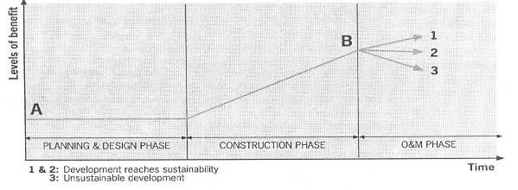
CHAPTER 3
FRAMEWORK FOR DEVELOPING A COMMUNITY WATER SUPPLY
3.1 Introduction
Typically engineers focus their efforts on the selection of technology and locating a suitable water supply source. The basic principle as recommended by Engineers Without Borders--USA and other organizations including the World Health Organization is that
communities need to be involved in selecting their water system from the start of the process. To achieve this, it is recommended that several feasible options be designed and offered for consideration and modification by the community.
3.2 Framework for community water-supply development
To select the most appropriate water system, EWB-USA suggests that the selection process include these steps:
- Request for improved services
- Conduct a preliminary assessment with participation by the community
- Analyze the data
- Develop several designs if requested by the community that will meet the needs
- Hold discussion with the community to review and allow them to select the design
- Obtain a formal written agreement

3.2.1 Request improved services The community requests support from a government agency or an NGO to improve their community water supply. The request should preferably be in writing and originate from a recognized community group or leader.
3.2.2 Conduct a preliminary assessment The supporting group, such as the EWB university chapter, conducts a baseline survey that includes needs and problem analysis. All the points listed below should be considered. See Chapter 4 for more specific water quantity and quality assessment techniques:
- What is the adequate level of service needed? Take into account gender preferences and the availability of the water source.
- What are the advantages and disadvantages of the different technologies?
- What are the motivations, expectations, and preferences of the users?
- What is the present system and how is it maintained?
- What are the causes and effects of poor operation and maintenance of the present system?
- What reliable sources of water are available?
- Can the source provide the required quantity and quality of water needed through all seasons of the year?
- What water treatment is needed? Can this treatment be provided at the point-of-use or for the entire system?
- Can all social groups benefit?
- What materials, replacement parts, and skills are needed to sustain the system?
- What structure is needed to manage and sustain the desired level of water service?
- What are the capital and operation and maintenance costs of the options considered?
- What technical, financial, and capacity-building assistance does the community need and expect?

3.2.3 Analyze the data
The analysis of the field data collected will lead to a range of technology options and differing levels of service. To choose the most appropriate technology, the options can be weighted with respect to the following factors:
Technical aspects
- Can the source provide an adequate supply in all seasons?
- What is the most appropriate water treatment?
- How much technical knowledge is needed to operate the system?
- What technological design is working in nearby communities?
- What materials are needed and how often?

Environmental factors
- Will the diversion of water affect important aquatic resources, especially for systems that use large volumes for irrigation purposes?
- How will the watershed be protected?

Management capacity
- What are the management options including legal and culturally appropriate approval to use the water source?
- Is there sufficient technology knowledge to manage each system being considered?

Financial sustainability
- What will it cost and is there funding available? Focus must be given to the long-term operational and maintenance cost recognizing that the most appropriate technology may not necessarily be the least cost. The least-cost technology can be costly to maintain or it may not be able to meet demand over the long-term because it was constructed with low-quality materials.
- How will the recurrent costs be recovered? The system should include shared financing responsibilities, options for fees, and the ability to manage these income sources.
- Are there community controls to minimize or prevent graft and corruption?

3.2.4 Develop feasible options
Developing feasible options helps focus the community on the advantages and disadvantages of differing systems. Community involvement in the selection improves the likelihood the system will become sustainable. Without alternatives water system designs to select from, there is not much of a decision for the community to make.
3.2.5 Hold discussions with the community
Discussions should be held with the community on the technology options. Each option should be discussed with special focus on the long-term management of each system. Any adjustments to the design can be selected. The persons responsible for development and maintenance should be defined.
3.2.6 Come to a formal agreement on the chosen technology
Once the community has made an informed choice for their water system, a formal agreement should be obtained between the community and all involved partners. When formulating this agreement, the following should be considered:
- Is the system affordable, manageable, and maintainable by the community?
- Are there grants or low-interest loans available?
- Will all members of the community benefit?
- Who will take care of preventive maintenance, repairs and protect the watershed?
- How will the ongoing costs of the system be recovered and organized?
- What type of contribution is the community going to provide in the initial investment?

CHAPTER 4
CONDUCTING A WATER QUANTITY AND QUALITY ASSESSMENT
4.1 Selecting the source for the community water supply
When selecting a water supply, the rationale or basis for selecting a particular water source should be carefully considered. The source of the raw water may be ponds, streams, or springs depending on proximity and availability through out the year. Water sources may differ due to taste and this factor alone may affect the community acceptability of a source. If users believe that a water supply ‘improvement’ is something that tastes ‘worse’ or otherwise is less desirable in any aspect, they may return to their traditional, contaminated sources. Water systems using chlorine, for example, may have an odor and taste so that it will be necessary to explain the need for disinfection to users.
The following options for community water sources and different intake systems are not exhaustive, but includes the most commonly used sources in developing countries.
4.1.1 Rainwater from rooftop harvesting
Rooftop catchments gather rain from buildings using gutters and down pipes that lead to storage. Designs need to include foul-flushing to allow the first millimeter or more of rain to be diverted from storage. This prevents dust, insects, or bird droppings and other debris from contaminating water in storage. Yields from rooftop harvesting are approximately 1 liter per square meter per millimeter of annual rainfall. The quantity produced is typically only sufficient for drinking water purposes. Rooftop harvest is typically applied in arid or semiarid climates where other sources are unavailable or difficult to protect. Periodic cleaning and shock chlorination of the storage tank can result in a safe and healthy rooftop harvesting system without the need for continuous disinfection. Chlorination may be necessary to assure no presence of fecal coliform contamination, however, well managed and maintained systems using foul-flushing and secure tanks are likely to have a low risk of contamination.
Gutter cleaning and cutting overhanging trees
Maintenance of roof collection systems is simple, but cannot be overlooked. Maintenance includes cleaning gutters and removing vegetation above the roofline. The use of disinfection agents such as mild chorine bleach for cleaning of the roof, gutter, and down sprouts will improve sanitation; which is especially important in systems that do not rely on chlorination for disinfection.
Foul-flush diversion
The simplest method to bypass the first portion of the rain is to install detachable or movable downspouts (Figure 4.1). However, this method relies upon the user to move the downspout. Another method is to install a small tank that must fill before water flows to storage. The foul flush tank has a small hole in the bottom that allows the water to be released prior to the next rainfall.
Figure 4.1 Rainwater Harvest System
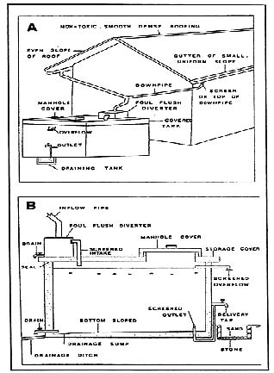
Pre-filters of sand and gravel
Routing the rainwater through a filter of sand and gravel can further reduce the organic material load entering the storage tank. Some systems mount the sand and gravel filter on top of the roof above the storage. Periodic removal of leaves and insect parts from the uppermost sand layer and replacement with clean sand will be necessary.
4.1.2 Catchments and storage dams
Water can be provided by placing a small dam and storing the water on the surface or below the surface in sand or gravel to prevent evaporation. Dams are usually constructed of compacted earth with a clay core, stone facing on abutments and a spillway to route overflow without damaging the dam. Water stored behind a dam will normally require disinfection before entering the community distribution system. For safety reasons, such systems are usually no more that a few meters high. This type of storage is used in hilly or mountainous terrain where other water sources are limited. If the dams are to be higher than several meters then a geotechnical stability analysis will be needed. Once a year, the reservoir may be allowed to dry out to reduce the danger of schistosomiasis.
4.1.3 Bank-side intake
A protected bank-side intake provides a stable site next to the stream or lake for water to flow to a chamber and then flow by gravity or pump (Figure 4.2). It needs to be built to withstand floods and to avoid filling with stream sediments. These intakes are usually reinforced concrete with a means of removing sediment accumulation. The water from the stream is screened prior to entry and a spillway is proved for routing overflow. Any erosion of the river bank will need to be repaired with boulders of sufficient size. It is frequently preferable to establish well-rooted perennial vegetation upstream of the bank inlet to provide for bank stability.
Figure 4.2 Stream Bank Intake
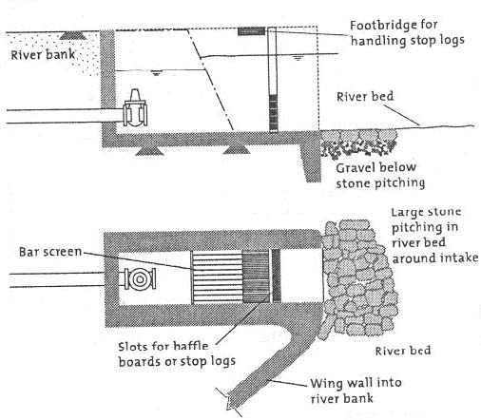
4.1.4 Spring water collection
Springs are ground water sources that discharge at the surface. When impermeable layers such as clay or dense rock types block the underground flow of water moving through the ground, the water is forced to the surface as a spring. Springs will not become cloudy with sediment during rain events. Collecting water from surface springs may provide a secure, drought-resistant source. Usually the spring water is of good quality without fecal coliform contamination, but this should be checked. Ground water exiting at springs can be contaminated by livestock that are concentrated either at the spring or at its source of recharge.
Proper spring development requires protecting the water supply from contamination. Concentrated springs that occur on hillsides are the easiest springs to develop and protect from contamination because surface flow is easily routed away from the spring collection point. Another type of spring is a low-area spring in gentle or flat terrain which may present greater challenge to control surface flow contamination. Seepage springs occur where groundwater seeps from the soil over a large area. These springs may need be collected over a wide area underground and then channeled to a collection point.
Box collection
Collecting water using a spring box is typically the least cost method requiring the least skill. A box is placed at the point of discharge that will route the flow to the collection pipe. While this method is simple to construct, it presents problems of insect and bacterial contamination within the box. Figure 4.3 below show cross-sectional drawings of typical designs for spring collection boxes (top shows a design for on a hillside or concentrated spring, bottom shows a design for flat terrain or low-area spring).
Figure 4.3 Spring Box Collection
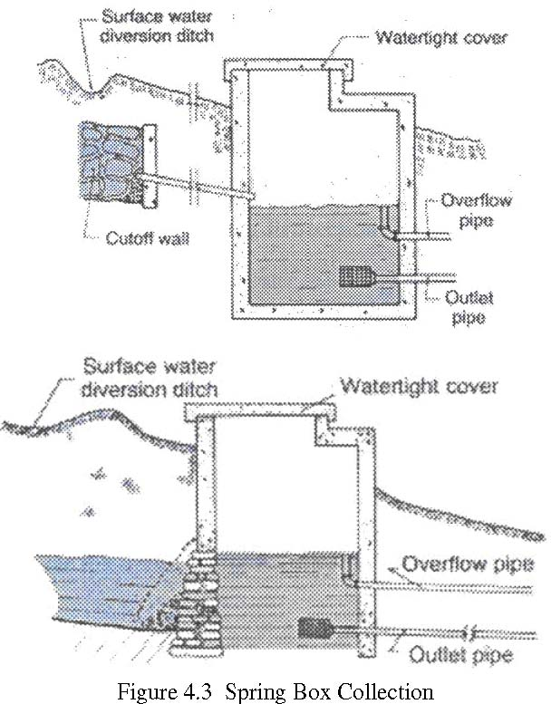
Underground collection with clay-filled collection trenches Springs can also be developed by installing two V-shaped trenches below the spring at least one meter below grade or where bedrock is encountered (Figure 4.4). A collector tile pipe is installed in the uphill V-shaped trench and clay or concrete is placed in the downhill trench to act as a cut-off wall allowing the spring to fill the collection trench. This method has an ecological advantage to the other methods since it is not necessary to dig within the spring and thus the aquatic organisms or wildlife relying upon the spring may not be affected.
Figure 4.4 Clay-filled collection trench for springs
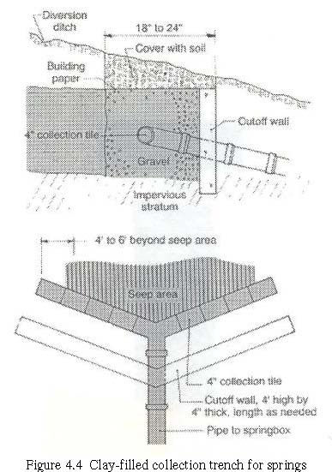
(See “Protecting Water Supply Springs”, by Gregory D. Jennings, North Carolina Cooperative Extension Service, 1996.)
Spring Disinfection
Springs are often contaminated with bacteria during construction or maintenance. New and repaired spring collection systems should be disinfected using shock chlorination. If bacterial contamination occurs on a regular basis, continuous chlorination may be necessary.
Shock chlorination requires concentration of at least 200 parts per million (ppm) chlorine. (As a point or reference, 200 ppm is the same proportion as 1 pound of salt in about 600 gallons of water.) To obtain this concentration, add 3 pints of liquid chlorine laundry bleach (such as "Chlorox," which is about 5 percent chlorine) for each 100 gallons of water to be disinfected. Other sources of chlorine are 1 pint of swimming pool disinfectant or concentrated bleach (at 12 to 17 percent chlorine) per 100 gallons of water or 4 ounces of high-test calcium hypochlorite tablets or powder (at 65 to 75 percent chlorine) per 100 gallons of water.
Follow these steps to disinfect spring-fed water systems:
- Remove debris and sediment from the spring box and distribution system. Scrub interior surfaces with a strong chlorine solution (1 gallon of liquid chlorine laundry bleach per 10 gallons of water).
- Disinfect the spring box by first allowing it to fill with fresh spring water. If the spring flow is small enough, plug the outlet pipe and add chlorine to the spring box to obtain the 200-part-per-million chlorine concentration. Hold the chlorinated water in the spring box for at least 12 hours. Keep the overflow pipe open. If the flow rate is too high to retain water in the spring box, feed the chlorine solution into the spring box continuously for at least 12 hours.
- Disinfect the water distribution system including pressure tanks, storage tanks, pipelines, valves, and faucets by pumping chlorinated water through the system. Open all faucets until a strong chlorine odor is detected at each outlet. Close the faucets to allow the chlorine solution to remain in the system for at least 12 hours.
- Open all valves and faucets to allow fresh spring water to flow through the system until no chlorine odor or taste can be detected.
- Test the spring water for bacterial contamination 24 hours after chlorine has been removed from the spring and household system.

4.2 Water Quality Assessment
Verifying the quality of any drinking water source is one of the most important aspects of any development project. Unfortunately, currently there is no international minimum water quality standard that can be applied worldwide, and each country, province, or even local municipality sets what they deem most appropriate for their community. Safe drinking-water, as defined by the WHO’s Guidelines for Drinking-water Quality, does not represent any significant risk to health over a lifetime of consumption, including different sensitivities that may occur between life stages. In these guidelines we will further refine this definition to include specific minimum standards that will be applied to all EWB projects worldwide.
4.2.1 Potential Pollutants
Creating a sustainable treatment system requires a thorough understanding of potential contaminants and their potential effects on human health. In addition to actual microbial and chemical contaminants, it is also important to evaluate the acceptability aspects of the drinking water.
Microbial Contamination
Microbial contamination is probably the most important water quality parameter to test for and treat, due to its acute and often very serious health effects. The most common source of microbial contaminates is when a water source comes in contact with human or animal feces. When this contact is made, often the concentration of the pathogen can increase rapidly, increasing disease risks and possibly triggering outbreaks of waterborne diseases. It is for this reason that the World Health Organization says that “The potential health consequences of microbial contamination are such that its control must always be of paramount importance and must never be compromised”.
Table 4.1 below lists some of the more common waterborne pathogens and their significance in water supplies. For more detailed descriptions of each of these contaminants, refer to the Microbial Fact Sheets in Chapter 11 of WHO’s Guidelines for Drinking-water Quality.
Table 4.1 Common Waterborne Pathogens (WHO)
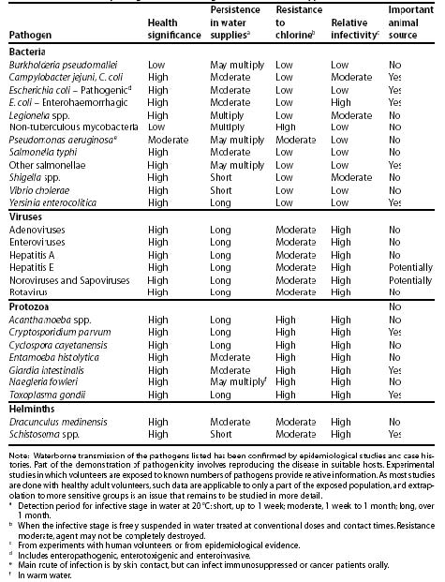While many of the pathogens listed above can have a significant impact on human health, it is often not feasible to test for all of these in a typical field based EWB project. For this reason, the focus of these guidelines will be on the most commonly tested “indicator” bacteria, E.coli. If a full laboratory testing facility is available it is highly recommended that a full regiment of water tests be run on a source sample before design begins. See section 4.2.2 for more information on testing equipment.
Chemical Contamination
Chemical contamination is another important water quality parameter that needs to be measured and tested for. Unlike microbial contamination that often has acute affects on human health, the risk for most chemical exposure is from long term chronic exposure. The primary exception to this is nitrate. There are many potential sources for chemical contamination of water sources, including pesticides, fertilizers, accidental spills, and in some places there can even be a natural occurrence of chemicals in groundwater. Examples of these sources of contamination are shown in Table 4.2 below and explained in further detail in the following section. For more detailed descriptions of each of these contaminants, refer to the Chemical Fact Sheets in Chapter 12 of WHO’s Guidelines for Drinking-water Quality.
Table 4.2 Common Contaminant Sources
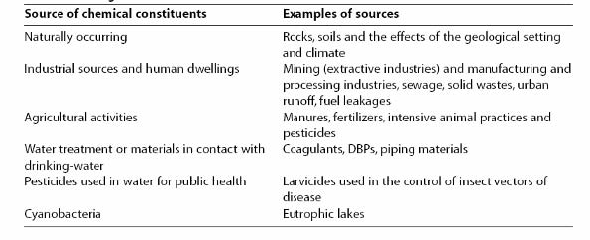
Naturally occurring chemicals
Naturally occurring chemicals are often some of the most difficult to treat because they do not usually have a identifiable point source, but rather leach from rocks and sediments that surrounding the water source. Several of the most common naturally occurring chemicals that have been shown to have an adverse health effect and their maximum allowable concentration (from WHO’s Guidelines for Drinking-water Quality) are listed in Table 4.3 below.
Table 4.3 Guideline Values for Naturally Occurring Chemicals
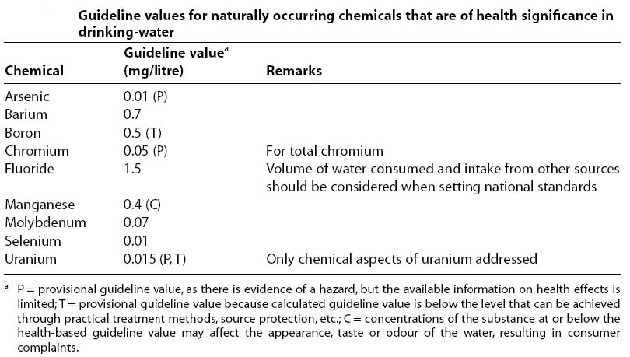
Chemicals from industrial sources and human dwellings
A variety of industries use chemicals for their processes and often these chemicals are not properly disposed of and contaminate drinking water supplies. This is particularly true in developing countries where no coordinated hazardous waste collection and disposal system exists. In addition to industrial contamination, an increasing number of household products have hazardous chemicals in them and are often disposed of with regular household wastewater. Chemicals from industrial sources and human dwellings that have been shown to have an adverse health effect and their maximum allowable concentration (from WHO’s Guidelines for Drinking-water Quality) are listed in Table 4.4 below.
Table 4.4 Guideline Values for Chemicals from Industrial Sources
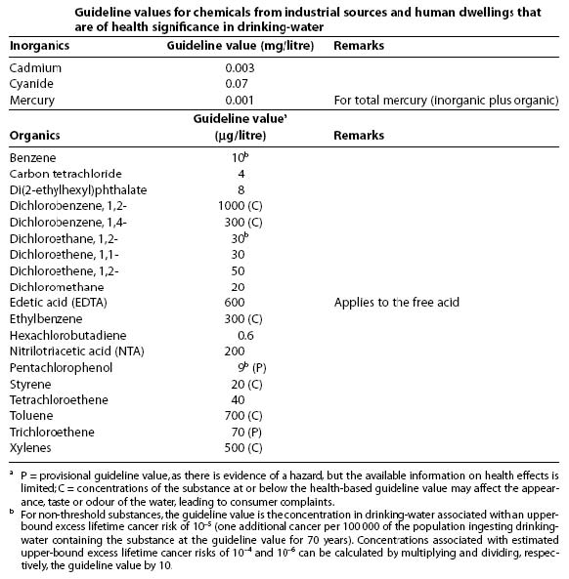
Chemicals from agricultural activities
Since the industrial revolution, an increasing number of agricultural and livestock husbandry activities have used chemicals. Pesticides, herbicides, fungicides and fertilizers all have a variety of chemicals in them that have made their way into surface and groundwater sources worldwide. Chemicals from agricultural activities that have been shown to have an adverse health effect and their maximum allowable concentration (from WHO’s Guidelines for Drinking-water Quality) are listed in Table 4.5 below.
Table 4.5 Guideline Values for Chemicals from Agricultural Activities
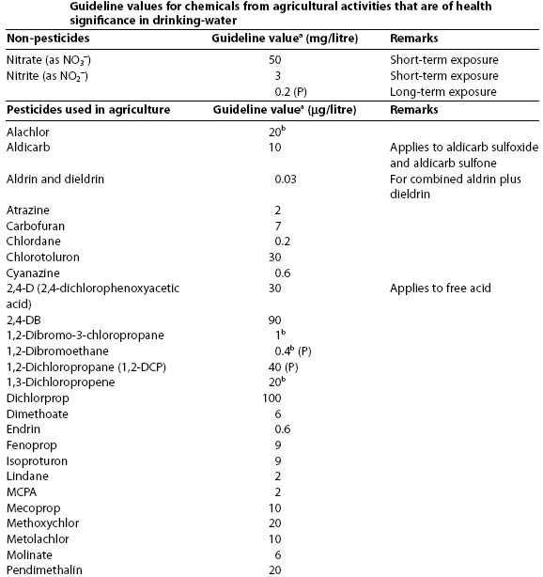
Chemicals used in water treatment or from materials in contact with drinking-water
Many drinking water plants use chemicals as part of their treatment process and in some occasions these chemicals can react to other constituents in the water to form dangerous byproducts. Some chemical additions such as chlorine and monochloramine are added to disinfect microbial contaminants and are beneficial, but high levels of these chemicals can also harm public health. In addition, many of the materials used in distribution systems can leach potentially dangerous chemicals into the water. Chemicals used in water treatment and distribution that have been shown to have an adverse health effect and their maximum allowable concentration (from WHO’s Guidelines for Drinking-water Quality) are listed in Table 4.6 below.
Table 4.6 Guideline Values for Chemicals Used in Water Treatment
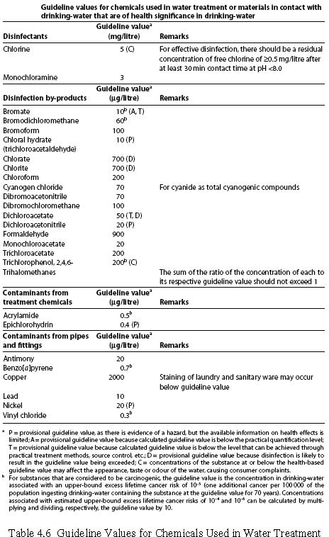
21
Pesticides used in water for public health purposes
In some countries, certain pesticides are added to drinking water to control the larval stages of insects to prevent widespread disease outbreak. Most commonly these are used to control mosquito populations in areas with malaria or typhus risk. Although only pyriproxyfen has been approved by the WHO for this type of treatment, several other pesticides have been used in the past (including chlorpyrifos & DDT) and may be persistent in groundwater supplies. Chemicals used as pesticides for disease vector control that have been shown to have an adverse health effect and their maximum allowable concentration (from WHO’s Guidelines for Drinking-water Quality) are listed in Table 4.7 below.
Table 4.7 Guideline Values for Pesticides for Public Health Purposes
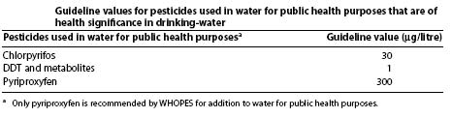
Radiological Contaminants
Although there is some possibility of radiological contamination of drinking water from natural, artificial, or human made sources, the detection and treatment of these contaminants is well beyond the scope of most EWB projects. If historical review of a community reveals potential radiological contamination of a drinking water source, consider finding a different source or finding a specialist to analyze the extent of the problem. For further information regarding radiological contamination of drinking water refer to Chapter 9 of WHO’s Guidelines for Drinking-water Quality.
4.2.2 Water Quality Testing
All EWB projects that will be installing, repairing, or retrofitting a drinking water system will require field testing of the quality of the drinking water source. Given the short time frame and remoteness of most site assessment trips, it is often necessary to limit the number of parameters that are tested, but the team should try to get as clear of picture as possible as to the quality of the source water. If available, it is recommended that a sample of the source water be run through a full barrage of tests at an accredited water quality laboratory. Unless the laboratory is close enough to the testing site to run daily tests, however, this should not be a substitute for field testing.
Water Testing Kits
There are many water quality testing kits available that can test a variety of different parameters, but in order to collect uniform data across all EWB projects, two specific kits are recommended for field testing of source water; the Hach MEL/850 Potable Water Laboratory and the OXFAM DelAgua Water Testing Kit (Table 4.8). Both of these kits are designed for field use and test for general parameters needed for a basic water quality assessment.
Water Quality Parameter | Hach MEL 850 | DelAgua
Fecal Coliforms (P/A) | X
Total Coliforms (P/A) | X
Fecal Coliforms (Counts) |  | X
Total Coliforms (Counts) |  | X
Turbidity | X | X
pH | X | X
Chlorine | X | X
Conductivity | X | X
Nitrate | X
Nitrite | X
Phosphate | X
Sulfide | X

Table 4.8 Water Test Kit Parameters
These kits are recommended for most field sampling applications, but if a project requires specific parameters that are not included in these kits, check with water quality testing vendors for other products that will meet that need.
Sample Data
Since most EWB project trips are fairly short in length, it is necessary to collect enough valid data to be able make design decisions once the trip is over. At a minimum, samples should be collected on a daily basis at the water source. If possible, sample at multiple locations around a distribution system. For communities of 5000 people or larger the WHO’s Guidelines for Drinking-water Quality should be followed when collecting samples (Table 4.9).
Table 4.9 Recommended Minimum Sampling (WHO)
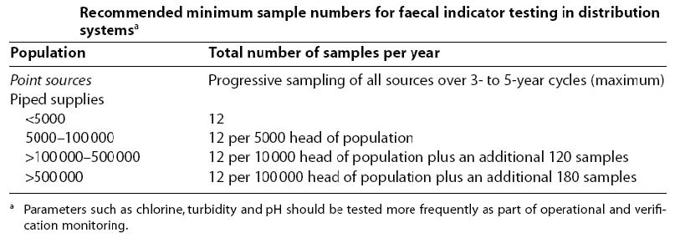
CHAPTER 5
WATER TREATMENT TECHNIQUES
5.1 Point of Use Treatment Techniques
The following recommended water treatment methods are intended to be used at the household level, or point-of-use, and are intended for emergency purposes until a more sustainable cost-effective community scale system can be implemented. The recommended methods are driven by solar energy and/or gravity since fuel to distill water may not be available or have its own environmental concerns, such as deforestation.
The point-of-use treatment methods described in this section were selected as appropriate as they provide effective removal of most physical and microbiological pollution and can be constructed at low-cost with little or no need of chemicals. However, pollution from fertilizer and industrial waste will not normally be removed by these discussed below and advice from experts in the field should be sought for these situations.
The use of chlorine is not a recommended point-of-use water treatment method due to the difficulty of deciding appropriate dosing levels, storage of chemicals, discharging chlorinated water, and obtaining the chemicals on an individual level.
5.1.1 Filtration and Aeration
The effectiveness of the point-of-use methods is highly dependent on the water quality and turbidity of the source water. If the source water appears questionable as to potential for contamination and if the turbidity level is greater than 20 NTU, filtration and aeration should be implemented as the first step prior to point-of-use treatment. Straining the water through clean cloth filters will remove a certain amount of silt and suspended solids. Monofilament cloths also remove such organisms as copepods which act as intermediate hosts for guinea-worm larvae. Rapid sand filters (Figure 5.1) or simply allowing the source water to settle in containers for at least 24 hours prior to decanting into clean containers (e.g., WHO’s 3-Pot method – see Internet Resources) are effective in reducing suspended solids and pathogen levels.
Figure 5.1 Upflow Rapid Sand Filter (Heber, 1985)
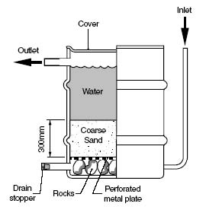
Aeration through roughing filters and other methods increases the oxygen level in the source water which removes volatile substances such as hydrogen sulfide and methane that affect taste and odor. Dissolved minerals such as iron and manganese are oxidized in the aeration process so that they form precipitates that can be removed during filtration.
Internet Resources – Filtration and Aeration
WHO/SEARO – Technical Note No. 5 “Emergency Treatment of Drinking Water – Point of Use” http://doultonusa.com/doulton_water_filters/Emergency-treatment-of-drinkingwater.htm
5.1.2 Solar Still Water Purification
Water sources may contain pollutants that are difficult to remove using filtration and disinfection methods but can be utilized if distilled, either by the sun or by other heat sources. Distilling is the process of evaporation followed by condensation. Solar stills are effective in removing:
- Salts/Minerals (e.g., Na, Ca, As, Fl, Fe, Mn)
- Bacteria (e.g., E. Coli, Cholera, Botulinus)
- Parasites (e.g., Giardia, Cryptosporidium)
- Heavy Metals (e.g., Pb, Cd, Hg)
- Radio nuclides or pesticides

A solar still consists of a shallow basin typically made up of the basic components shown on Figure 5.2. The bottom of the basin is a black fiber reinforced plastic to absorb solar heat effectively and the top is covered with transparent and tempered glass tilted and oriented towards the noon sun so that maximum solar radiation can be transmitted in to the still. The edges of the glass are sealed to the basin so that the entire basin becomes air tight. Water is charged, usually by daily dosing, into the basin in a thin layer. The heat of the sun evaporates the raw water in the basin and the distilled water is collected on the underside of the collector surface and routed to storage. Water is then collected and stored in a container that can be cooled by storage in the earth. Solar distilled water is palatable with no odor or taste, very low in salt content (less than 10 mg/l total salinity) and all organic and inorganic pollutants will be removed. Typical rates from stills in the south-western United States and near Juarez, Mexico ranged from approximately 7 liters per square meter in the summer to half of this in the winter months.
Figure 5.2 Basic Components of a Solar Still
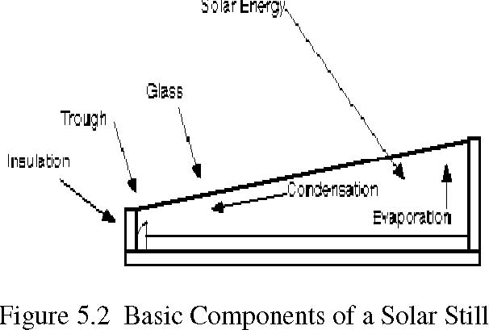
Internet Resources
El Paso Solar Energy Association http://www.txses.org/epsea/stills.html Vendors – SolAqua Inc. of El Paso, Texas http://www.solaqua.com/
5.1.3 Filtron – Potters For Peace
Since 1998, Potters for Peace (PFP) has been developing a low-tech, low-cost, colloidal silver-enhanced ceramic water filter; the Filtron. The Filtron is a colloidal silver-impregnated ceramic filter constructed from pulverized clay (60 percent by weight) and screened sawdust (40 percent by weight). The sawdust (corn or rice husks can also be used) is combusted during the 900° C firing process, allowing the ceramic pot to be porous. This porosity allows the filter to flow at a rate of approximately 1 to 2 liters per hour. The colloidal silver is then mixed with water and applied to the outside of the filter with a paintbrush. The colloidal silver is used to destroy any single celled bacteria, viruses, or fungi. Field experience and clinical test results have shown this filter to effectively eliminate approximately 99.88% of most water born disease agents and has been cited by the United Nations' Appropriate Technology Handbook.
Internet Resources -Filtron
Potters for Peace organization http://www.potpaz.org
5.1.4 Solar Water Disinfection – SODIS
SODIS (Solar Water Disinfection) was developed by EAWAG/SANDEC (The Swiss Federal Institute for Environmental Science and Technology/Department of Water and Sanitation in Developing Countries) and simply involves filling a plastic two-liter bottle ¾ full of source water and setting the bottle on its side in the afternoon sunlight for approximately 6 hours (two consecutive days under mostly cloudy skies), or until a water temperature of at least 50° C is achieved. The SODIS system is effective only in warm climates with abundant sunlight. Sunlight treats the water using two synergistic mechanisms: temperature increase and UV-A radiation. As with any UV water treatment, turbidity can inhibit the effectiveness of the SODIS system.
The containers most frequently used are 1 to 2 liter PET (polyethylene terepthalate) bottles, commonly used for soft-drinks. PET bottles are the preferred treatment container because they are durable, more translucent than glass, and contain less UV-stabilizers than plastic bottles made from PVC (polyvinyl chloride). The system can be enhanced by painting the back half of the bottle black to increase heat gain (clear side facing sun).
Internet Resources -SODIS
EAWAG/ SANDEC -http://www.sodis.ch/
5.1.5 Ceramic Candle Filters
Water may be purified by passing through ceramic “candle” filters that are impregnated with colloidal silver and are operated by gravity or siphoning (hand suction pumps can also be used), as shown on Figure 5.3. A candle without the colloidal silver will remove suspended particles, but will require boiling or chemical disinfection.
When the filter becomes clogged with sediment, a nylon brush can be used to remove the amassed slime. Each cleaning removes some ceramic and after a few cleanings, the filter needs to be replaced. Most ceramic candle filters come with a kit that includes a circular gauge that can be slipped over the candle to evaluate when the filter needs to be replaced.
Figure 5.3 Candle Filter Operation
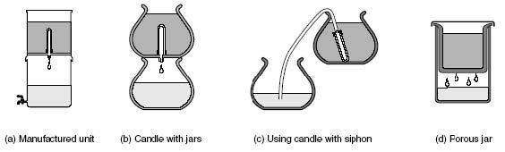
Internet Resources – Ceramic Candle Filters
WHO/SEARO – Technical Note No. 5 “Emergency Treatment of Drinking Water – Point of Use” http://doultonusa.com/doulton_water_filters/Emergency-treatment-of-drinkingwater.htm
5.1.6 PuR Water Treatment Packets
For emergency uses, or if other point-of-use technologies are not practical, Procter & Gamble has developed an easy to use, effective water purifying kit. PuR Purifier of Water packets contain powder (ferric sulfate and calcium hypochlorite) that when mixed with water remove pathogens and cause particles to settle to the bottom of the mixing container.
The PuR water purification process involves simple implements that consumers have in their homes.
- Add one sachet to 10 liters (or 2.5 gallons) of water and stir to begin process of precipitation and coagulation.
- Stir water for five minutes until clear.
- Filter water through a clean cotton cloth and dispose of separated floc in latrine.
- Let clear water stand for 20 minutes to allow for complete disinfection.
- Store in a suitable container to prevent recontamination.

Internet Resources –PUR Water Treatment Packets
Proctor & Gamble -http://www.pghsi.com/safewater/development.html PSI -http://www.psi.org/our_programs/products/pur.html
5.2 Community Scale Treatment
The following techniques are intended for community scale treatment. These systems will often require a capital investment by the project team and community, but are a more sustainable long term approach to providing potable water to a community. One or more water quality assessments must be completed before starting design of any of these systems.
In addition to the design and construction of any community scale water treatment system, the project team is responsible for training of operators and working with the community to establish a sustainable operations and maintenance fund to keep the system up and running over the long term.
The following techniques are presented as possible treatment methods and should not be considered as complete design guides. Nor should this be considered a complete list of all treatment techniques. Project teams are expected to research and design systems that are most appropriate for the source water quality and community resources. Sources for specific design guidelines are referenced with each treatment method.
5.2.1 Sedimentation Tanks
One of the easiest ways to remove large suspended particles from a water source is through sedimentation. This process simply reduces the velocity of the incoming water stream to the point where these heavier particles will settle out of the water by gravity. Sedimentation tanks are particularly effective when they are used as a pre-treatment process before a filter. Sedimentation tanks can be designed to operate on a continuous basis or in batches. The main design considerations for a sedimentation tank are listed below:
- Settling Velocity: The most important parameter in sizing a sedimination tank is the settling velocities of the suspended particles. The settling velocity is affected by the density and size of the particle, but also by the temperature of the water. Since these can vary significantly from place to place, it is necessary to determine these parameters for the water supply using “jar tests”. To perform a jar test, stir the sample water; pour it into a jar; and time how long it takes for the water to become clear. Often you will see a layer of dirt particles on the bottom of the jar, but sometimes you may only notice a clear layer of water near the top. The settling velocity is the depth of clear water divided by the time it takes to become clear.
- Surface Area: The surface area of the tank is calculated by dividing the design flow rate (m3/day) by the settling velocity (m/day). A tank can be either circular or rectangular.
- Depth of Tank: A typical depth for a sedimentation tank is about 1.5 to 2.5 meters deep. It is important to remember to allow for the build up of a certain amount of sludge.
- Detention Time: The detention time for a sedimentation tank will vary with your particle density and water temperature, but typical values are from 0.5 to 3 hours.
- Sludge Removal: Regardless of whether the tank is operated as a continuous or batch process, eventually the accumulated solids, or sludge, will have to be removed from the tank. Often this means that a tank will have to be taken out of service while an operator physically goes into the tank and removes the sludge manually, so, if feasible, two tanks should be designed to operate in parallel to maintain continuous treatment.

Internet Resources – Sedimentation Tank
“Designing a Small Community Sedimentation Basin”:
http://www.lifewater.org/resources/rws3/rws3d2.pdf
“Constructing a Sedimentation Basin”:
http://www.lifewater.org/resources/rws3/rws3c2.pdf
“Operating and Maintaining a Sedimentation Basin”:
http://www.lifewater.org/resources/rws3/rws3o2.pdf
RedR – Engineers for Disaster Relief, Jan Davis and Robert Lambert, “Engineering in Emergencies: A Practical Guide for Relief Workers”, ITDG Publishing, 1995
5.2.2 Filtration
Filtration is a basic technique for straining source water through a media that has small pore spaces and filters out large particles. The effectiveness of this technique largely depends on the size of the particles in the source water and the pore size of the media. It can be as simple as using a cotton t-shirt to filter soil particles and as complicated as reverse osmosis that requires high pressure and a membrane with pore sizes on the nanometer scale. This section will focus on some of the most commonly used filters for water sources in developing countries.
Slow Sand Filter
The SSF is a relatively efficient design that can typically be constructed using local resources and is effective in removing impurities through sedimentation, adsorption, straining, and chemical/biological processes. The SSF design requires the components described below:
1. Housing: Tanks with non-reactive surfaces such as plastic, concrete, fiberglass, or lined galvanized tanks with a capacity of at least 200 liters are appropriate for housing filters. Clay can be used for the housing, but is typically not very durable.
2. Supernatant: The supernatant water, above the filter sand, should have a constant depth between 0.5 -1.5 m to supply the hydraulic head to drive the water treatment. Influent water turbidity should be less than 20 NTU (maintenance intervals shorten with water greater than 20 NTU and may not function at all when the water is greater than 200 NTU). A detention time of at least two hours is required to settle out solids and provide a temperature buffer for the biological layer, or “schmutzdecke”, that develops on the sand filter surface.
3. Schmutzdecke (Biological Layer): The biologically active film (composed of bacteria, fungi, protozoa, rotifera, and a plethora of aquatic insect larvae) grows on the surface of the sand filter and helps water purification by breaking down pathogens into inorganic compounds such as carbon dioxide, nitrates, sulfates, and phosphates. Larger aquatic organisms, such as endoprocta, snails and annelid worms, inhabit the film as the system matures. The schmutzdecke typically develops within three to seven days following implementation.
4. Filter Sand: The filter sand, directly underneath the schmutzdecke, should be at least one meter deep in order to allow sufficient percolation time and address the need for scraping the surface during ordinary operation and maintenance. The sand filter supplements the biological treatment in the Schmutzdecke. The filter sand should have maximum and minimum diameters of 3 mm and 0.1 mm, respectively, with an effective grain size (characterized by D10, or sieve size through which 10 percent of the sand passes) between 0.15 and 0.35 mm. The Cu (uniformity coefficient, or ratio of sieve sizes through which 60 percent and 10 percent of the sand passes -D60/D10) should be less than 3. The filter pack gradation allows relatively high water to grain surface contact for adsorption while maintaining a percolation rate between 0.1 m/hour and 0.3 m/hour (ideal rate is 0.2 m/hour). It is essential that the sand be washed through sieves to remove fine and organic material before being placed in the SSF.
5. Underdrain Medium: The underdrain gravel layers (the finer gravel is directly below the sand filter) envelops pipes that discharge to the clean water storage.

The time interval for cleaning the sand filter is dependent on the turbidity of the influent and filtration rate. In general, filter run times are typically between 2 and 25 weeks. An ordinary filter cleaning requires the scraping off a thin top layer of the schmutzdecke to increase water flow. If the filter becomes air-locked or contaminated from deposits, the filter may need to be back-washed.
Because the biological film requires two to seven days to re-develop after each maintenance routine, constructing at least two SSFs for system redundancy is highly recommended. The second SSF should be placed in operation approximately seven days prior to routine maintenance to maintain a constant supply of water for the community. Operators must be trained to maintain a constant flow rate, constant head, and temperature.
Another type of SSF is the Oxfam filter. The Oxfam SSF incorporates a synthetic fabric on top of the sand filter to reduce the amount of sand removed during cleaning. During the cleaning process, the water is lowered to approximately 200 mm below the sand. The fabric is removed from the tank and washed, reducing the operation and maintenance time and the need for running two parallel filters. This design does not break down pathogens and requires disinfection prior to drinking.
Internet Resources -SSF
“Biosand Filter: Biological Action”: http://biosandfilter.org/biosandfilter/index.php/item/ “Slow Sand Filter Bed”: http://en.wikipedia.org/wiki/Slow_sand_filter_bed “Slow Sand Filtration”: http://www.oasisdesign.net/water/treatment/slowsandfilter.htm “Slow Sand Filtration”:http://ewr.cee.vt.edu/environmental/teach/wtprimer/slowsand/slo wsand.html WHO/SEARO – Technical Note No. 5 “Emergency Treatment of Drinking Water – Point of Use” http://doultonusa.com/doulton_water_filters/Emergency-treatment-of-drinkingwater.htm
RedR – Engineers for Disaster Relief, Jan Davis and Robert Lambert, “Engineering in Emergencies: A Practical Guide for Relief Workers”, ITDG Publishing, 1995
Rapid Sand Filter
A Rapid Sand Filter (RSF) differs from a Slow Sand Filter mainly by the size of the sand used and by the flow rate through the filter. Like the SSF, a RSF operates the principle of mechanical straining and physical adsorption but since it has an increased pore size it can operate up to 40 times faster. With this increase in speed, however, there is also a large increase in maintenance due to the method of cleaning the filter, discussed below.
A RSF filter bed requires the components as described below:

- Housing: Tanks with non-reactive surfaces such as plastic, concrete, fiberglass, or lined galvanized tanks. Capacity depends on the amount of water that will be treated on a daily basis. A typical flow rate through a RSF is about 1 to 2 gallons per minute per square feet (gpm/ft2) of surface area.
- Filter Sand: The filter sand for an RSF ranges in size from 0.35 to 1.0 mm, with a coefficient of uniformity of 1.2 to 1.7. A typical size might be 0.5 mm, with an effective size of 1.3 to 1.7 mm. The sand layer can be anywhere from 1 to 2 meters thick depending on the turbidity of the source water.
- Underdrain Medium: The underdrain system is similar to the SSF in that it is usually a layer of fine gravel enveloping a series of perforated pipes. Usually this layer is about 30 cm thick with a preferred gravel size of about 5 -60 mm.
- Backwash System: The most important part of a RSF is the backwash system. To clean the filter and maintain flow rates it is necessary to backwash the system by reversing the flow of water through the entire filter bed on a regular interval (often daily). This can be accomplished using backwash pumps or designing a self backwashing system using adjustable weir gates. Because of the rapid flow rates through the filter, it is necessary to train the operators how to recognize when the filter needs to be cleaned or set up a daily backwash schedule.

A rapid sand filter can be very effective for eliminating large particles and turbidity from a water source, but care must be taken to properly train operators on how to clean the system. If the filter is not maintained, it will quickly clog up and be ineffective. This must be considered and discussed with the community prior to design.
Internet Resources -RSF
“Sand Filtration”: http://www.usace.army.mil/publications/armytm/tm5-662/chap12.pdf
“SIZING A RAPID SAND FILTER”: http://www.usace.army.mil/publications/armytm/tm5-662/app-f.pdf "Sand filtration: rapid versus slow”: http://www.biosandfilter.org/biosandfilter/index.php/item/316
5.2.3 Disinfection
Disinfection is probably the most important part of any drinking water treatment system. Since bacterial contamination is the most likely source of public health risks, it is almost always necessary to disinfect a water source before putting into a distribution system to be used. While there are a variety of different methods used to disinfect drinking water in the United States, very few of them are applicable to typical EWB projects due to high cost, high energy demand, and technical complexity. For this matter, these guidelines will mainly focus on disinfection using Chlorine and discuss how some of the technological improvements in UV disinfection may make it a viable sustainable technique.
Chlorine
Chlorine is the most commonly used disinfectant for water supplies worldwide. It has a low cost, is readily available anywhere, and is effective against a wide range of pathogens. It also comes in several forms so there are several options to choose from depending on local supply conditions. There are also many different ways of dosing water supplies with chlorine so it is important to choose a method that is most appropriate for a specific project design. Specific dosing techniques will be discussed below. Important chlorine disinfection design points are discussed below.
- Turbidity: Chlorine is most effective when a water source has a turbidity of less than 5 NTUs, but will work for turbidities up to 20 NTUs. Above that, it loses it’s effectiveness quickly. If a water source has high turbidity, the water must be treated through a filter or sedimentation tank to reduce the turbidity before disinfection.
- Chlorine Demand: Chlorine demand is simply the amount of chlorine that is needed to oxidize all of the contaminants in the water. Since chlorine will also react with organic and inorganic substances in the water, the demand will be higher if there are a large amount of these substances in the source water.
- Chlorine Residual: In addition to meeting chlorine demand, it is also important to leave a “residual” in the water to prevent further contamination in the distribution system. Usually a residual of 0.2 to 0.5 mg/L after minutes of contact time will meet this requirement.
- Chlorine Dose: The total dose of chlorine will depend greatly on the quality of the water to be disinfected, but will usually be in the range of 1-5 mg/L. To determine the actual dose needed for your water use the following steps:
- Taste and Smell: It is important not to overdose a water supply with chlorine. At high doses (or at high turbidity levels), chlorine can give off an unpleasant odor and/or taste that may cause a community to turn off the chlorine dosing or use another, possibly unsafe, water source.
- Safety: Chlorine is a very reactive and corrosive chemical and care should be taken when handling it. Gloves and protective clothing should be worn to protect the skin and care should be taken not to inhale the fumes.

a. | Get five 1-liter samples of your water source in clean containers
b. | Dose your samples with a varying doses of chlorine from 1 to 5 mg/L
c. | Let the samples sit for 30 minutes
d. | Test each sample for chlorine residual using a color comparator kit or test
 | strips. You design dose should be the sample that still has 0.2 to 0.5 mg/L
 | of chlorine left.
e. | Note that in countries that have a distinct monsoon season, the water
 | source should be tested in both the dry and rainy seasons as chlorine
 | demand can vary significantly. If this is the case, it is especially important
 | to train the operators on how to test for residual and adjust the dose.

Chlorine can be found in many forms and strengths. It is important to take the amount of free chlorine available in a particular type of chlorine. Table 5.1 adapted from RedR’s
“Engineering for Emergencies” lists several common types of chlorine, the amount of available chlorine and the quantity required to make 1 liter of 1 percent solution.
Chlorine Source | Available Chlorine, % | Quantity required | Approx. measure
High Test Hypochlorite (HTH) granules | 70 | 14 g | 1 heaped tablespoon
Bleaching Powder | 34 | 30 g | 2 heaped tablespoons
Stabilized tropical bleach | 25 | 40 g | 3 heaped tablespoons
Liquid Household Disinfectant | 10 | 100 ml | 7 tablespoons
Liquid Laundry Bleach | 5 | 200 ml | 14 tablespoons
Antiseptic Solution | 1 | 1 liter | No need to adjust as it is a 1% solution

Table 5.1 Preparation of 1 liter of 1 percent chlorine solution
Chlorine Dosing Equipment
Chlorine dosing equipment can vary almost as much as the types of chlorine, but they generally fall into three categories:
- Batch dosing of a fixed volume of water.
- Constant rate dosing of water flowing at a steady rate.
- Proportional dosing at a rate proportional to the variable flow rate of the water.

Batch dosing can be fairly effective for short term solutions or on a household level, but won’t work very effectively for a large scale community water source. Proportional dosing requires a way to effectively gauge the flow rate of the water, which is possible using differential pressure as show below, but is generally difficult in small scale projects. By far, the most common method of dosing chlorine is with constant dosing of water that does not have a lot of flow variation. Some suggested chlorine dosing systems are shown below:
Pot Chlorinator
A pot chlorinator is simply a earthen pot that is filled with a mixture of sand and bleaching powder and lowered into a well or tank. This type of system holds about 1.5 kg of chlorine and can effectively treat 1000-1500 L/day for about one week. Although it is fairly simple, it will require weekly maintenance and refreshing of sand and bleaching powder.
Figure 5.4 Pot Chlorinator (Lifewater International)
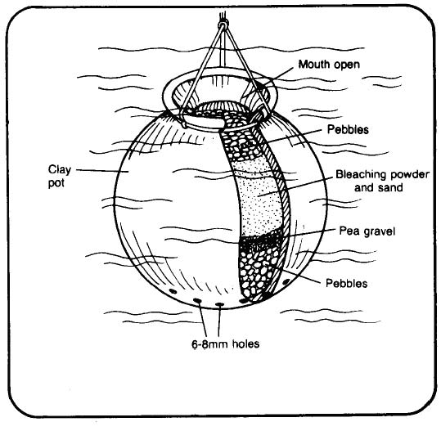
Drip Chlorinator
Drip chlorinators are a commonly used method of disinfection in the developing world. The basic concept has a chlorine holding tank with a floating feed tube (Figure 5.5). The feed tube floats near the surface of the liquid and slowly draws in a consistent amount of chlorine which is then dripped into the water source. It takes some effort to properly calibrate a drip system to feed a proper amount of chlorine into the water, and it is necessary to properly maintain the system to prevent blockages and to maintain chlorine levels in the storage tank. It is also somewhat difficult to adjust the feed rate of the chlorine if there is a change in the incoming water flow rate.
Figure 5.5 Drip Chlorinator (Lifewater International)
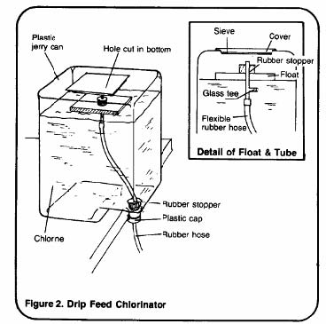
Floating Bowl Chlorinator
Floating bowl chlorinators are another common type of drip chlorinator (Figures 5.6 and 5.7). It consists of a large storage tank for the chlorine solution and a “floating bowl” to provide a consistent chlorine dose to the water supply. It has some of the same as the drip feed chlorinator, but because the weight of the bowl controls the dosing rate, it can be adjusted if the flow rate of the water changes.
Figure 5.6 Floating Bowl Chlorinator (WHO, 2003)
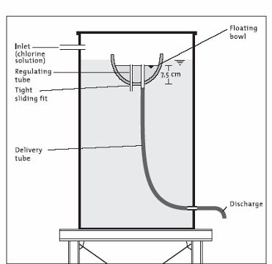
Figure 5.7 Floating Bowl Chlorinator (Lifewater International)
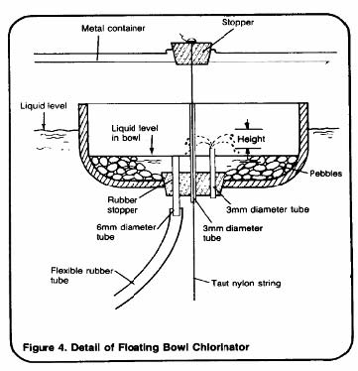
Shock Chlorination
Shock chlorination is a means of disinfecting a contaminated system, but should not be used as a sustained disinfection process. Shock chlorination usually entails introducing large doses of chlorine to a storage tank, well, or distribution system that has been shown to have been contaminated. This method will effectively destroy all bacteria in the system and can be used to clean out a system after construction or bacterial bloom. After the chlorine has completely reacted with the contaminants, no residual remains and there is no longer any disinfection occurring. If a contaminated source is reintroduced into the system, it will become contaminated once again. Shock chlorination also exposes a community to high levels of chlorine and can affect fish when disposed of in natural waterways. Shock chlorination should be used sparingly and only under the supervision of a trained professional.
Internet Resources – Chlorine Disinfection
“Linking technology choice with operation and maintenance in the context of community water supply and sanitation: A reference document for planners and project staff”:
http://www.who.int/water_sanitation_health/hygiene/om/wsh9241562153/en/index.html
“Designing a Small Community Disinfection Unit”:
http://www.lifewater.org/resources/rws3/rws3d4.pdf “Constructing a Disinfection Unit”: http://www.lifewater.org/resources/rws3/rws3c4.pdf “Operating and Maintaining a Chemical Disinfection Unit”:
http://www.lifewater.org/resources/rws3/rws3o4.pdf “Chlorinating small water supplies” : http://www.lboro.ac.uk/well/resources/wellstudies/full-reports-pdf/task0511.pdf
RedR – Engineers for Disaster Relief, Jan Davis and Robert Lambert, “Engineering in Emergencies: A Practical Guide for Relief Workers”, ITDG Publishing, 1995
UV Disinfection
UV disinfection is another system of disinfection that uses the ultraviolet spectrum of light to disrupt the DNA of pathogenic organisms and prevent them from reproducing. Although this method of treatment has been used for many years in the developed world, it was often though too expensive and energy intensive for use in small scale developing communities. Recently, however, there has been some progress in developing inexpensive units for these communities and as such they could be considered for implantation if appropriate. It is important to note that while UV is an effective disinfectant, it does not provide a residual to protect against contamination in the distribution system. If a residual is required, additional chlorination may be necessary.
Internet Resources – Chlorine Disinfection
“An Overview of Sustainable Drinking Water Disinfection for Small Communities in the Developing World”:
http://www.cee.mtu.edu/peacecorps/documents_july03/Disinfection_FINAL.pdf “The UV-Tube Project”: http://ist-socrates.berkeley.edu/~rael/uvtube/uvtubeproject.htm “Water Health International”: http://www.waterhealth.com/products.html#household
CHAPTER 6
WATER DISTRIBUTION
The design of a water distribution system from source to community requires knowledge of the generally accepted engineering practices in addition to an understanding of the politics of ownership (of the water and system), maintenance, and locations of distribution points to avoid marginalizing a portion of the community. This section provides a practical, general guideline for water source development engineering and distribution including basic engineering principals and providing references.
Typically, the rights to the water source and the final distribution system can be the most political part of the pipeline network (as discussed in Section 1). Much consideration should be taken to identify the system ownership, operation and how many distribution points will be required to provide equal access to the water for all members of the community.
6.1 Pipe Materials
The transmission of water by gravity from source to distribution can use numerous systems such as canals, ditches, and aqueducts. However, only a pipeline distribution system can increase or decrease pressure when the system has to traverse steep and/or uneven terrain. The typical pipe materials used are polyvinyl chloride (PVC), polyethylene (PE), and galvanized steel (GI). General specifications for each material are discussed in the following section.
When selecting the appropriate pipe material, the primary consideration is availability of the material and the expense to the community. All attempts should be made to use locally available pipe in order to facilitate maintenance and repairs by the community members. Note: Although the purchase of pipe locally is recommended for continued operation and maintenance and replication, it is suggested that in absence of proof of pipe quality that a lower pressure class is assumed in design (See Section 3.4).
6.1.1 Polyvinyl Chloride (PVC) PVC and uPVC (unplasticized PVC) materials are resistant to many ordinary chemicals such as acids, bases, salts and oxidants. However, PVC is not typically resistant to ultraviolet radiation (UV) damage unless the pipe is specified to include the addition of stabilizers to enhance the ability to resist UV degradation. Carbon black is a black pigment, which can also enhance mechanical properties as well as act as an excellent UV stabilizer when properly compounded into a plastic or rubber. Above grade installations may not be the best application for PVC.
Sizes and Pressure Classes
Nominal outside diameters are typically found ranging from 16 mm to 160 mm and available in standard 4 m and 6 m pipe lengths. The pressure ratings are typically given for a maximum temperature of 27° C for the metric series. Pipe standard diameters, pressure ratings and even colors are dependent on the nation where the pipe was manufactured. Therefore, determining the source of pipe is critical for design. For example, Table 6.1 includes pipe standards for uPVC pipe from Thai Pipe Standards (TIS).
Nominal Pipe Size, mm | Outside Diameter, mm |  | Wall Thickness |  |  | Weight per Length, Kg (length is 4 m)
Nominal Pipe Size, mm | Outside Diameter, mm | PVC 5 |  | PVC 8.5 | PVC 13.5 | PVC 5 | PVC 8.5 | PVC 13.5
20 | 26 | - |  | 2±0.2 | 2.5±0.2 | - | 0.86 | 1.06
40 | 48 | 1.5±0.15 |  | 2.3±0.2 | 3.5±0.25 | 1.25 | 1.89 | 2.8
80 | 89 | 2.5±0.2 |  | 4.1±0.3 | 6.4±0.4 | 3.89 | 6.26 | 9.5
100 | 114 | 3.2±0.25 |  | 5.2±0.35 | 8.1±0.5 | 6.37 | 10.17 | 15.41
150 | 165 | 4.6±0.3 |  | 7.5±0.45 | 11.7±0.65 | 13.28 | 21.29 | 32.37
200 | 216 | 5.4±0.35 |  | 8.8±0.5 | 13.7±0.75 | 20.48 | 32.87 | 50.06

Table 6.1 Standards for Drinking Water Service uPVC Pipe (TIS 17-2532)
Note: Working Pressures of uPVC pipes class PVC 5, PVC 8.5, and PVC 13.5 are 5, 8.5 and 13.5 kg/cm2 respectively.
The two most common PVC pipe standards (ASTM) used in the United States are schedule 40 and 80. Nominal diameters, wall thicknesses and maximum operating working pressures for non-shock conditions at 73° F are shown in Table 6.2.
 |  | SCHEDULE 40
Nominal Pipe Size, in. | Outside Diameter (OD), in | Average Inside Diameter (ID), in | Nominal Weight per foot, lbs | Maximum Working Pressure (WP), psi *
½” | 0.840 | 0.602 | 0.170 | 600
1” | 1.315 | 1.029 | 0.333 | 450
2” | 2.375 | 2.047 | 0.720 | 280
3” | 3.500 | 3.042 | 1.488 | 260
4” | 4.500 | 3.998 | 2.118 | 220
5” | 5.563 | 5.016 | 2.874 | 190
6” | 6.625 | 6.031 | 3.733 | 180

 |  | SCHEDULE 80
Nominal Pipe Size, in. | Outside Diameter (OD), in | Average Inside Diameter (ID), in | Nominal Weight per foot, lbs | Maximum Working Pressure (WP), psi *
½” | 0.840 | 0.526 | 0.213 | 850
1” | 1.315 | 0.936 | 0.424 | 630
2” | 2.375 | 1.913 | 0.984 | 400
3” | 3.500 | 2.864 | 2.010 | 370
4” | 4.500 | 3.786 | 2.938 | 320
5” | 5.563 | 4.768 | 4.078 | 290
6” | 6.625 | 5.709 | 5.610 | 280

Table 6.2 Working Pressures for Schedule 40 and 80 PVC Pipe
40
Temperature De-Rating
When the pipe network is operating in elevated temperatures above 27° C (approximately 80° F), the working pressure (WP) of the pipe system should be multiplied by a de-rating factor as shown in Table 6.3.
Operating | De-Rating Factor
Temperature
23° C (73° F) | 1.00
27° C (80° F) | 0.88
32° C (90° F) | 0.75
38° C (100° F) | 0.62
43° C (110° F) | 0.51
49° C (120° F) | 0.40
54° C (130° F) | 0.31

Note: The maximum service temperature for PVC is 60° C (140° F).
Table 6.3 De-Rating Factors
Joining PVC Pipe
PVC pipe less than 4-inches in diameter is typically joined by primer and solvent cement. However, push-fit connections may be available and are typical for pipe diameters greater than 4 inches. PVC pipe is typically buried, but can also be used above ground if the pipe is protected from traffic (livestock, foot and wheel) and contains stabilizers and UV inhibitors to shield against ultraviolet radiation. When joining PVC pipe and fittings with solvent cement, always consider the following procedures:
1. Pipe must be cut as square as possible (A diagonal cut reduces bonding area in the most effective part of the joint).
2. Some plastic tubing cutters may produce a raised bead at the end of the pipe. This bead must be removed with a file or reamer, as it will wipe the cement away when pipe is inserted into the fitting.
3. Remove all burrs from both the inside and outside of the pipe with a knife, file or reamer.
4. Remove dirt, grease and moisture (moisture will retard cure, and dirt or grease can prevent bonding).
5. Check the dry fit of pipe and fittings before cementing.
6. Priming: The purpose of a primer is to penetrate and soften the surfaces so they can fuse together. Next aggressively work the primer on to the end of the pipe, to a point 1.25 cm (1/2") beyond the depth of the fitting socket. Immediately, and while the surfaces are still wet, apply the appropriate solvent cement.
7. Cementing: (Stir the cement or shake can before using). Aggressively work a full even layer of cement onto the pipe end equal to the depth of the fitting socket. Do not brush it out to a thin paint type layer, as this will dry within a few seconds. Without delay, while cement is still wet, assemble the pipe and fittings. Use sufficient force to ensure that the pipe bottoms in the fitting socket. If possible, twist the pipe a 1/4 turn as you insert it.
8. Hold the pipe and fitting together for approximately 30 seconds to avoid push out.
9. After assembly, a joint should have a ring or bead of cement completely around the juncture of the pipe and fitting. If voids in this ring are present, sufficient cement was not applied and the joint may be defective.
10. Using a rag, remove the excess cement from the pipe and fitting, including the ring or bead, as it will needlessly soften the pipe and fitting and does not add to joint strength. Avoid disturbing or moving joint.
11. Handle newly assembled joints carefully until initial set has taken place.
12. Follow set and cure times as shown in Table 6.4 as a guideline.

Pipe Diameter, mm (in) | Movement of Joint Allowed, minutes | 100 Percent of Working Pressure, hours
Hot Weather – 32 to 60° C (90 to 140° F) Surface Temperature
25 (1”) | 15 | 4
50 (2”) | 30 | 6
75 to 100 (3” to 4”) | 45 | 8
>100 (over 4”) | 60 | 10
Mild Weather – 10 to 32° C (50 to 90° F) Surface Temperature
25 (1”) | 20 | 5
50 (2”) | 45 | 8
75 to 100 (3” to 4”) | 60 | 15
>100 (over 4”) | 90 | 20
Cold Weather – -18 to 0° C (0 to 50° F) Surface Temperature
25 (1”) | 30 | 7
50 (2”) | 45 | 10
75 to 100 (3” to 4”) | 80 | 18
>100 (over 4”) | 110 | 30

Table 6.4 Cure Time for PVC Pipe
6.1.2 Polyethylene (PE) Pipe
Polyethylene (PE) is a thermoplastic material produced from the polymerization of ethylene. PE is usually first categorized by its density as indicated in the abbreviations
e.g. HDPE (high density PE), MDPE (medium density PE), LDPE (low density PE), and LLDPE (linear low density PE). PE pipe typically comes in two types: blue for below ground use and black for above ground use, though in practice both types are resistant to UV light to several years.
PE pipes can be used in low temperatures -18° C (0° F) or colder without risk of brittle failure. In addition, the high impact strength and the flexibility of PE (can be bent to a minimum bending radius of 30 times the pipe's outside diameter for HDPE and 20 times the pipe's outside diameter for MDPE) makes PE a good choice for use in water distribution applications. PE pipe is recognized as acceptable plumbing piping for water services, drainage, and sewer applications in most model plumbing codes.
Sizes and Pressure Classes
PE plastic pipe is manufactured by extrusion in sizes ranging from ½" to 63" and is available in rolled coils of various lengths or in straight lengths up to 40 feet. Generally small diameters are coiled and large diameters (>15 cm OD) are in straight lengths. PE is available in many varieties of wall thicknesses, selected by the designer on the basis of the required working pressure for the pipe. The term Standard Dimension Ratio (SDR) is a unitless term that relates the pipe outside diameter (OD) to the pipe wall thickness. The higher the SDR number, the thinner the pipe, and the lower the overall pressure rating.
The most typical PE pipes and the pressure ratings that are obtained are shown in Table
6.5 below. Again, if the nation of manufacturing is known, specific standards should be researched.
PE Density | OD, mm | SDR | Pressure, bar (psi)
 | 20-63 | 11 | 12 (174)
MDPE | 90-315 | 11 | 10 (145)
 | 90-1000 | 17.6 | 6 (87)
 | 90-500 | 11 | 16 (232)
HDPE | 90-500 | 17.6 | 10 (145)
HDPE | 160-1000 | 26 | 6 (87)

Table 6.5 PE Pipe OD and Pressure Ratings
Joining PE Pipe
There are several joining methods available for PE pipe systems. The fusion welding of the pipe creates joints that are as strong as the pipe itself and are able to withstand hydraulic end thrust from internal pressure. As a consequence, thrust blocks are typically not required at changes of direction which saves installation time. Some common joining methods are described below.
Butt Welding -PE pipe systems can be joined by butt welding to provide homogeneous joints. Preheated pipes and/or fittings are joined under controlled pressure and temperature conditions. The final weld is as strong as the pipe itself.
Stub Flanges and Backing Plates -PE pipes can be flange-jointed by using PE stub flange ends in conjunction with metal backing plates and rubber sealing gasket to provide a demountable joint or to match up with pumps, valves etc.
Mechanical Compression Joints -PE pipes 16mm to 160mm outside diameters may be joined by mechanical compression fittings. This enables jointing of PE/PE or PE to other pipe materials without the need for power or special tools.
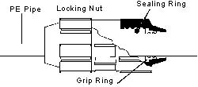
(Graphics reproduced courtesy of Vinidex, Inc.: http://www.vinidex.com.au/ )
Although PE joints are very strong, the ability to obtain fusion welding equipment or parts for mechanical joints may not be readily available. The availability of parts and equipment should be considered when designing a sustainable water distribution system.
6.1.3 Galvanized Steel Pipe
Galvanized steel (GI) pipe is more expensive and rougher (higher loss of head due to friction) than plastic pipe. and much more rigid. However, GI is much more rigid and there are certain cases when GI pipe may be selected:
- Pipe sections subject to high pressure.
- Pipe sections that cannot be buried such as hard rock areas.
- Exposed to the environment over ravine crossings.
- The amount of soil cover is not sufficient to distribute stress from traffic.
- Exposed pipework (e.g., tapstands and tanks).

Galvanized pipe is galvanized internally and externally. However, the galvanized finish is removed when cutting new threads which can result in corrosion at the joints.
Sizes and Pressure Classes
GI pipe is commonly available in 3 or 6m lengths in diameters of up to 100 mm (4 in.). A common source of GI pipe uses the British Standards (BS 1387) for size and working pressures, included in Table 6.6. Steel tubes are categorized as Light, Medium and Heavy.
However, only medium and heavy pipes provide the practical rigidity for threaded joints. GI pipe manufactured internationally may not comply with the standards stated in this section. When possible, samples of pipe obtained from the project location should be brought back for further testing and investigation to evaluate wall thickness and appropriate strength.
Nominal Pipe Size, mm | Thread, in | Medium |  |  | Heavy
Nominal Pipe Size, mm | Thread, in | Wall Thickness, mm | Meters per tonne | Pressure, bar | Wall Thickness, mm | Meters per tonne | Pressure, bar
15 | ½ | 2.6 | 787 | 35 | 3.2 | 667 | 42
20 | ¾ | 2.6 | 610 | 35 | 3.2 | 516 | 42
25 | 1 | 3.2 | 398 | 35 | 4.0 | 329 | 42
32 | 1 ¼ | 3.2 | 309 | 28 | 4.0 | 254 | 35
40 | 1 ½ | 3.2 | 268 | 28 | 4.0 | 220 | 35
50 | 2 | 3.6 | 190 | 24 | 4.5 | 156 | 31
65 | 2 ½ | 3.6 | 148 | 24 | 4.5 | 121 | 31
80 | 3 | 4.0 | 114 | 21 | 5.0 | 93 | 28
100 | 4 | 4.5 | 78 | 17 | 5.4 | 66 | 21
125 | 5 | 5.0 | 57 | 17 | 5.4 | 53 | 21
150 | 6 | 5.0 | 48 | 14 | 5.4 | 45 | 17

Table 6.6 BS 1387 GI Pipe Weight and Working Pressure
Source: British Steel plc, Tubes & Pipes
Joining GI Pipe
GI pipe is usually supplied with tapered pipe threads at both ends and connected to other pipes with a straight connector per pipe. Joining the pipe requires:
- Clean the threads to remove surface rust, dirt and any previously used jointing compound.
- Check for any damaged pipe thread or deformed ends. If the pipe thread is damaged, or the pipe ends are deformed, the section should be cut off and the pipe re-threaded.
- Water-tight joints are made by wrapping PTFE tape around the thread in a clockwise direction prior to joining pipe sections.
- Do not over-tighten threaded joints as they can be damaged or cracked.

To allow for valves to be removed for repair, join threaded GI pipe with screwed unions on at least one side of a valve or fitting (both sides are preferable).
Metal pipes can become very hot when exposed to direct sunlight. In order to avoid the pipes from getting too hot, store the GI pipe under cover or slightly bury the pipe in a long trench (keeping the joints exposed). Also, be careful not to fill the pipes with very cold water as sudden contraction can damage the pipe at the threaded joints, causing them to leak.
6.2 Valves
The most common valves used in a water pipeline system are described in this section and shown on Figure 6.1.
- Gate, ball and butterfly valves are used to control flow rate.
- Check (non-return) valves only allow flow in one direction.
- Float valves automatically maintain the water level in a tank by closing the valve at a set water level to prevent overfilling, or maintain a constant pressure.
- Air valves are usually placed at high points in a pipeline to allow accumulated air trapped in a pipe to escape and to let air enter when the pipe is empty.
- Pressure reducing valves (also see Section 3.4.2.1 for description of break-pressure boxes).

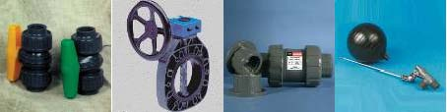
Ball Valve Butterfly Valve Check Valve Float valve
Figure 6.1 Typical Valves Used in Water Distribution Systems
6.3 Design Parameters and Considerations
A sustainable water distribution system uses gravity to drive the system and has been designed to offer a long service life with little to no maintenance. In practice, most systems require maintenance, cross uneven terrain (creating critical pressure points), and often need pumps to drive the system. The following design parameters should be considered prior to designing a water system.
6.3.1 Delivery Rate The water distribution system should be designed to deliver approximately 0.2 liters/second (l/s) with a residual head of 3 meters at each tapstand. Rates greater than 0.2 l/s may waste water at the delivery points and lower rates may result in long lines waiting to fill containers. Perforation or tap sizes can be sized to increase or decrease flows where decreasing pressure is undesirable an/or increasing head is not possible.
Velocities in the pipeline should be kept between 0.7 m/s and 2 m/s. Sedimentation may clog pipes at velocities lower than 0.7 m/s and excessive scouring of the pipe (causing a higher friction value) may result at velocities greater than 2 m/s. Velocities greater than 2 m/s may also tend to “kick” when closing off distribution valves as the system quickly returns to the static pressure head. Design considerations should look at normal day use, peak hour and peak day loads to evaluate storage and final delivery needs.
6.3.2 Pipe Protection Where the pipe is above ground, or buried less than 0.3 m below ground, and exposed to traffic (livestock, foot and wheel) the system requires additional protection. This may be achieved in any number of methods including: double casing, GI pipe, construction of barriers, and covering the pipeline with rock (a minimum layer of 1-foot).
6.3.3 Distribution The number of taps and distance from dwellings on a water system should use minimums of 200 people per tap at 0.2 l/s (SPHERE recommends 250 people per tap at 0.125 l/s) and that no dwelling is located greater than 500 m from a tap.
The tapstand should be designed with positive drainage away from the tap to prevent standing water. The drainage should be directed towards a trough for livestock, a garden, or soak pit (if the soils have a percolation rate faster than 25 minutes per cm) as shown on Figure 6.2. Without such measures in place, the standing water will quickly create unsanitary conditions and an environment suitable for insects.
Figure 6.2 Tapstand and Drainage Schematic
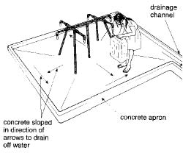
Simple Branch or Ring Main The geometry of the distribution system considers the geographical layout of the village (straight road ways or narrow winding paths) and has a direct influence on pipe size calculations. The use of a ring main should be considered as flow can move in two directions, thereby reducing the chances for complete system blockages. The ring main also reduces the frictional losses on the system by reducing the flow path. The branched distribution is often used as it provides an easier system to install (e.g., along existing roads) and more access to the water given a limited pipe length. A schematic of the two systems is shown on Figure 6.3.
Figure 6.3 Distribution Systems
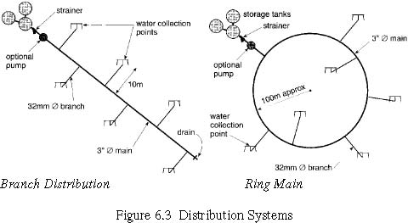Branch Distribution Ring Main
6.4 Pipeline Hydraulic Design
In order to effectively move water from the source supply to distribution points with sufficient pressure, the pipeline needs to account for head loss (friction and local losses) and the hydraulic grade line along the length of the system. The major head loss component is the sidewall friction along the pipe length and is directly dependent on the pipe material, age and condition. Local losses are attributed to the joints and bends.
6.4.1 Frictional Head Loss
The basic equation relating the total energy of a unit mass of water in a fully developed, steady flow pipe (pressurized) is Bernoulli’s equation:
Pv 2
H = ++ z
ρg 2g
Where:H = total energy, (m) P = Pressure of water, (Pa, N/m2) ρ = density of water, (N/m3)
g = gravitational acceleration, (m/s2) z = height of water above a datum, (m) The three components of the equation are: pressure energy (pressure within pipeline), kinetic energy (difference between the total energy and hydraulic gradient), and potential energy (elevation above the datum). These components are shown on Figure 6.4 below.
Figure 6.4 Energy Components in Steady Pipe Flow (RedR)
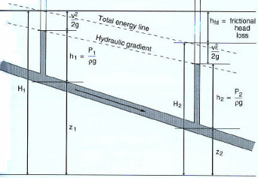
The difference in slope between the energy grade line (EGL) and the hydraulic grade line (HGL) is due to the velocity head loss. Positive pressure is maintained in the system when the HGL is above the pipe profile and negative pressures when the HGL dips below the profile and then back above the profile, causing air-locks that reduce or even stop flow (see 3.4.4.2 Design Example).
Darcy-Weisbach Equation
The Darcy-Weisbach equation with the Moody diagram are considered to be the most accurate model for estimating frictional head loss in a fully developed, steady, incompressible flow. The Darcy-Weisbach equation for head loss can be expressed as:
Lv 2
HL = f
D 2g
Where: HL = head loss (Length) g = acceleration of gravity in(Length/Time/Time) L = pipe length (Length) d = pipe diameter (Length) v = flow velocity (Length/Time) f = friction factor
The above equation can be used with any set of consistent units. The friction factor is described by the Moody diagram and is generally a function of the Reynolds number (Re) and the relative roughness of the pipe,ε (determined by the ratio of the roughness
coefficient to the pipe diameter). An empirically derived equation can be used to represent the turbulent portion of the Moody diagram (0.01>ε >10-6, 108>Re>3000).
−0.9 −2
f = 1.325[ln(0.27 ε+ 5.74 Re )]
Hazen-Williams Equation
The Hazen-Williams formula is an alternative method of calculating frictional head loss in a water pipeline system. The following forms are for SI units.
1.85 1.85
10.9LQ 4.72 LQ
hf = (SI units) hf = (Imperial Units)
1.85 4.87 1.85 4.87
CD CD
Where:
hf = head loss, (m, ft) L = length of pipe, (m, ft) Q = flow, (m3/s, ft3/s) C = Hazen-Williams coefficient (see Table 6.7) D = internal diameter (ID), (m, ft)
Material | Hazen-Williams C | Darcy-Weisbach e (millifeet)
Cast Iron | 130 -140 | 0.85
Concrete | 120 -140 | 1.0 – 10
Galvanized Iron | 120 | 0.5
PE, PVC | 140 -150 | 0.005
Steel | 140 -150 | 0.15

Table 6.7 Coefficients for Head Loss Formulas
6.4.2 Secondary Frictional Losses – Minor Losses
Energy in a pipe system is also lost at pipe entry, exit, changes of pipe diameter and direction, and fittings. The lost energy is expressed in terms of lost head (height lost above the datum). There are several methods of estimating the losses.
♦ A reasonably accurate method is to express secondary losses in terms of the velocity head in the pipe:
2
v
h = k (values for k are included in Table 6.8)
LL L
2g
Geometry | Lk | Geometry | Lk
Globe valve (fully/half open) | 7.5 | Bellmouth entrance | 0.1
Gate valve (fully/half open) | 0.1 | Plain suction entrance | 0.9
45 degree elbow | 0.4 | Square-edged entrance | 0.5
90 degree elbow | 1.0 | Pipe exit | 1.0

Table 6.8 Minor Loss Coefficients
♦ If the pipe length is sufficiently large compared to pipe diameter (i.e, L/D>1000), it is common to neglect minor losses. However, caution is recommended as secondary losses can be significant. Therefore, when insufficient information is provided, a rough estimate of secondary losses can be estimated by adding five percent of the length before calculating the major frictional loss.
6.4.3 Negative and Excessive Pipeline Pressures
Many water distribution systems encounter uneven terrain and ravines (see Section 3.5 Pipeline Installation) between the source and points of distribution. The major hydraulic challenges in community water pipelines with undulating slopes between source and distribution are points of negative pressure and too high of a pressure.
Negative pressure can develop when the hydraulic grade line (HGL) dips below the pipeline profile and reduction or stoppage of flow can result (Figure 6.4). Negative pressures can be avoided by reducing frictional loss in the upstream section with a larger diameter pipe.
The maximum pressure in a gravity-flow system is when flow is shut off at the distribution points and the system is subject to the static head of the source. Steep terrain can also create pressures that exceed the rated working pressure of the pipe. When pressures exceed the working pressure rating, a break-pressure tank should be installed. A small tank, or even a large diameter pipe extension can be used as a pressure-break to expose the water to atmospheric pressure. Inflow can be regulated by a float valve (Section 3.2) and excess water controlled by an engineered overflow. The effective use of pressure breaks (as discussed in the design example below) allows the system to be constructed from less expensive, lower pressure rated pipe.
6.4.4 Design Example
The difference in elevation between the level of water in the top tank and the pipe outlet is 63 m. The maximum difference in elevation between the tank and the lowest point of the pipe is 68 m. The required flow rate is 3 l/s over a distance of 1200 m from source to distribution. The pipe available at the site is PVC.
A pipe inside diameter (ID) of 0.054 m is initially selected for trial. The head loss was calculated as 39.5 m (using Hazen-Williams, C=150) and a hydraulic gradient of 0.033. This provides a residual head of 63 m – 40 m = 23 m. This is plotted on Figure 6.5.
Figure 6.5 Pipe Profile and HGL (RedR)
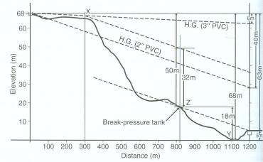
The initial selection of pipe results in a HGL that dips below the pipe profile within approximately 100 m of the source. This will cause negative pressures downstream that create air-locks that result in flow reduction and/or stoppage of flow.
Two potential remedies would either design the entire system with a larger diameter pipe (rated for the maximum static head pressure), or select a larger diameter section upstream of where the HGL dips below the pipeline profile. A 0.0762 m ID pipe would result in a head loss of only 7.4 m head loss and a hydraulic gradient of 0.005. While the HGL is above the pipe profile and negative pressures are avoided, the residual head of the system is 63 m – 7.4 m = 55.6 m. The entire pipeline would need to be designed using high pressure rated pipe.
One solution is to combine the two different diameter pipes with the break located where the negative pressure problem. From Figure 6.5, the head loss over the first 300 m of 0.0762 m (ID) pipe is 1.5 m, and the head loss over the remaining 900 m of 0.054 m (ID) pipe is 29.7 m – totaling approximately 31 m of head loss. This results in a residual head of 32 m for the system.
In order to reduce the pressure head to result in the designed residual head of 3 m at each tapstand is to include a break-pressure tank in the design, allowing the pipeline pressure to drop to atmospheric.
6.4.5 Hydraulic Design Software
EPANET is a free windows based (95/98/NT) hydraulic and water quality analysis simulation program for flow within a pressurized pipe network developed by the
U.S.E.P.A. (www.epa.gov). Software analysis of hydraulic pipeline routes allows for a quick analysis of routes and resulting pressures at distribution points along the system. However, the final pipeline layout should be analyzed by hand-calculations for good measure. EPANET has hydraulic modeling capabilities:
- No limit on the size of the network to be modeled.
- Computes friction head-loss using Hazen-Williams, Darcy-Weisbach, or Chezy-Manning formulas.
- Includes minor head losses for bends, fittings,…etc.
- Models constant or variable speed pumps.
- Computes pumping and energy costs.
- Models various types of valves including; shut-off, check, pressure regulating, and flow control valves.
- Allows storage tanks to have any shape (i.e., diameter can vary with height).
- Considers multiple demand categories at nodes, each with its own pattern of variation.
- EPANET can also model chlorine residual analysis to evaluate water quality following routine disinfection maintenance of the system (See Section 2).

6.5 Pipeline Installation
The installation of pipeline needs to be installed at a steady grade to match the design parameters and consider how the pipeline will cover uneven terrain, exposed rock, ravines, and unstable slopes.
6.5.1 Trenching and Installing
Pipe should be placed in a trench at a depth to allow protection from frost, traffic (foot, wheel, hoof), and UV damage. A trench depth of approximately 30 cm to 45 cm typically offers sufficient protection from traffic and UV damage. However, frost depth can range between 0 cm and 180 cm and should be determined based on conditions at the site. Do not open the trench too far in advance of laying pipe to avoid rains that may flood the trench (especially in clayey soils). The pipe can be placed directly in the trench were the native soils are in good uniform condition and the trench bottom can be readily brought to an even finish as to support the pipe evenly. If large stones or sharp protruding rocks are exposed along the trench bottom, bedding1 should be placed to even the grade and protect the pipe from damage. Pipes should be joined in the trench to avoid joint separation as the pipe is pushed into the trench.
If mechanical equipment is to be used to compact the backfill, the first 300 mm depth of fill above the crown of the pipe should be compacted by hand and should consist of selected, uniform, readily compactable material2 placed and compacted in uniform layers.
1 The ideal bedding material for the trench bed and for compacting is a soil gradation between 12 mm and 2 mm, but is free from very fine particles which may impede drainage. The thickness of bedding, when required, should be a minimum of 100 mm.
2 For the remaining backfill of the trench the ideal material should be free from large clay lumps, from stones larger than 3 cm, sharp edged stones and organic matter.
If the pipe is laid in weather that is cooler or warmer than normal working conditions (buried and carrying water) and expansion or contraction of the system may be a concern, precautions should be taken to allow for this movement after being backfilled. The best method to avoid pipe expansion/contraction is to allow the pipe to fill with water from its normal supply when the trench has only been partially back-filled, leaving the joints exposed for inspection. Allow the system to come to equilibrium over the next 24 hours. Before final backfilling, carefully examine the joints for leaks and any signs of undue stress. If contraction of the pipe still may be of concern, it may be helpful to snake the pipe in the trench. The contraction will then tend to straighten the pipe out, thus reducing any pull at the joints. Also, making an as-built map of the trench excavation (pipeline location and depth) will aid in future operation and maintenance of the system.
6.5.2 Pipe Anchors Pipes carrying water will have unbalanced forces at locations where there are changes in diameter, direction and grade. Pipes at bends should be anchored to resist the force that may loosen joints. Small concrete blocks (“kick blocks”) should be placed at these locations to reduce pipe vibration and the potential for joint separation. However, avoid covering the joints with the blocks to allow future repairs. Mechanical restrainst may be used in substitution or in conjunction with concrete kick blocks.
6.5.3 Ravine Crossings Many drainage crossings will require the suspension of the pipeline in order to avoid the potential for erosion, or if it is not hydraulically possible to cross the ravine with a gravity system. The type of suspension depends greatly on the width of the crossing and whether it is practical to sink piers into the ravine bottom. Two typical suspension systems are the cable-stayed bridge and the pier supported bridge.
Plastic pipelines (PE or PVC) that are exposed to the atmosphere and UV radiation, should either be double-cased in a larger diameter pipe for protection, or replaced with GI pipe. Also, when crossing ravines, flow control measures in the ravine must be taken to keep the work sites dry and safe.
Cable-Stayed Bridge
Ravines or gulleys that are relatively narrow (less than 10 m across) and the creek bottom conditions make the installation of pier supports difficult should consider a cable-stayed system that supports the pipeline with two upright towers on either bank. The cable-stayed design transfers the vertical gravitational force from the pipeline into tension in the ropes held by anchors.
The towers can be constructed by placing poles (material to be determined by designer) on buried reinforced concrete footers to distribute the vertical forces placed at least 1m below ground. A horizontal pole is then securely fastened to the two upright poles. The final tower height should be determined by a span to height ratio of approximately five. The cables (or ropes) will be inter-connected to form a saddle for the pipe to rest in. This saddle will eliminate the need to tie directly to the pipe and will allow for thermal expansion and contraction of the pipe. The tieback ropes will be drawn from the top of the tower down to the anchor system (buried log or concrete block) at 45 degree angles from the pipe.
Pier-Support Bridge
Cable-stayed bridges over ravines wider than 10m are subject to very high tensile forces and should be avoided. Ravines with more suitable ground conditions for anchored piers should construct anchored piers of two uprights spaced approximately two pipe diameters of the carrying pipe (outside pipe) apart. The piers should be constructed as described for the upright towers for a cable-stayed bridge. However, erosion protection should be designed if the piers are exposed to flood waters.
6.5.4 Unstable Slopes Landslides, rock-fall, and creep are all examples of mass wasting (erosional) processes in earth slopes. Installation of pipelines on unstable slopes can be done, but with caution and an investigation as to the slope movement. Deposits of mass wasting are referred to as colluvium. While certain features are fairly evident of slope movement such as scarps and talus slopes, most creep type slope movement requires more detective type evaluation.
Creep is the slow, downslope movement of soil and/or unweathered rock caused by many phenomena such as freeze-thaw and groundwater saturation. Evidence that a hillside may be exposed to creep are “pistol-butte” trees (trees with a curved trunk). As trees tend to grow vertically but the slope is moving slowly downslope, the trunk of a tree may have this curved appearance.
REFERENCES
RedR – Engineers for Disaster Relief, Jan Davis and Robert Lambert, “Engineering in Emergencies: A Practical Guide for Relief Workers”, ITDG Publishing, 1995
䘀椀最甀爀攀㈀⸀㄀圀愀琀攀爀瀀爀漀樀攀挀琀挀礀挀氀攀猀਀
䘀椀最甀爀攀㐀⸀㄀刀愀椀渀眀愀琀攀爀䠀愀爀瘀攀猀琀匀礀猀琀攀洀
䘀椀最甀爀攀㐀⸀㈀匀琀爀攀愀洀䈀愀渀欀䤀渀琀愀欀攀
䘀椀最甀爀攀㐀⸀㌀匀瀀爀椀渀最䈀漀砀䌀漀氀氀攀挀琀椀漀渀
䘀椀最甀爀攀㐀⸀㐀䌀氀愀礀ⴀ昀椀氀氀攀搀挀漀氀氀攀挀琀椀漀渀琀爀攀渀挀栀昀漀爀猀瀀爀椀渀最猀
吀愀戀氀攀㐀⸀㄀䌀漀洀洀漀渀圀愀琀攀爀戀漀爀渀攀倀愀琀栀漀最攀渀猀⠀圀䠀伀⤀
吀愀戀氀攀㐀⸀㈀䌀漀洀洀漀渀䌀漀渀琀愀洀椀渀愀渀琀匀漀甀爀挀攀猀
吀愀戀氀攀㐀⸀㌀䜀甀椀搀攀氀椀渀攀嘀愀氀甀攀猀昀漀爀一愀琀甀爀愀氀氀礀伀挀挀甀爀爀椀渀最䌀栀攀洀椀挀愀氀猀
吀愀戀氀攀㐀⸀㐀䜀甀椀搀攀氀椀渀攀嘀愀氀甀攀猀昀漀爀䌀栀攀洀椀挀愀氀猀昀爀漀洀䤀渀搀甀猀琀爀椀愀氀匀漀甀爀挀攀猀
吀愀戀氀攀㐀⸀㔀䜀甀椀搀攀氀椀渀攀嘀愀氀甀攀猀昀漀爀䌀栀攀洀椀挀愀氀猀昀爀漀洀䄀最爀椀挀甀氀琀甀爀愀氀䄀挀琀椀瘀椀琀椀攀猀
吀愀戀氀攀㐀⸀㘀䜀甀椀搀攀氀椀渀攀嘀愀氀甀攀猀昀漀爀䌀栀攀洀椀挀愀氀猀唀猀攀搀椀渀圀愀琀攀爀吀爀攀愀琀洀攀渀琀
吀愀戀氀攀㐀⸀㜀䜀甀椀搀攀氀椀渀攀嘀愀氀甀攀猀昀漀爀倀攀猀琀椀挀椀搀攀猀昀漀爀倀甀戀氀椀挀䠀攀愀氀琀栀倀甀爀瀀漀猀攀猀
吀愀戀氀攀㐀⸀㤀刀攀挀漀洀洀攀渀搀攀搀䴀椀渀椀洀甀洀匀愀洀瀀氀椀渀最⠀圀䠀伀⤀਀
䘀椀最甀爀攀㔀⸀㄀唀瀀昀氀漀眀刀愀瀀椀搀匀愀渀搀䘀椀氀琀攀爀⠀䠀攀戀攀爀Ⰰ㄀㤀㠀㔀⤀
䘀椀最甀爀攀㔀⸀㈀䈀愀猀椀挀䌀漀洀瀀漀渀攀渀琀猀漀昀愀匀漀氀愀爀匀琀椀氀氀
䘀椀最甀爀攀㔀⸀㌀䌀愀渀搀氀攀䘀椀氀琀攀爀伀瀀攀爀愀琀椀漀渀
䘀椀最甀爀攀㔀⸀㐀倀漀琀䌀栀氀漀爀椀渀愀琀漀爀⠀䰀椀昀攀眀愀琀攀爀䤀渀琀攀爀渀愀琀椀漀渀愀氀⤀
䘀椀最甀爀攀㔀⸀㔀䐀爀椀瀀䌀栀氀漀爀椀渀愀琀漀爀⠀䰀椀昀攀眀愀琀攀爀䤀渀琀攀爀渀愀琀椀漀渀愀氀⤀
䘀椀最甀爀攀㔀⸀㘀䘀氀漀愀琀椀渀最䈀漀眀氀䌀栀氀漀爀椀渀愀琀漀爀⠀圀䠀伀Ⰰ㈀ ㌀⤀਀
䘀椀最甀爀攀㔀⸀㜀䘀氀漀愀琀椀渀最䈀漀眀氀䌀栀氀漀爀椀渀愀琀漀爀⠀䰀椀昀攀眀愀琀攀爀䤀渀琀攀爀渀愀琀椀漀渀愀氀⤀਀
䘀椀最甀爀攀㘀⸀㈀吀愀瀀猀琀愀渀搀愀渀搀䐀爀愀椀渀愀最攀匀挀栀攀洀愀琀椀挀
䘀椀最甀爀攀㘀⸀㌀䐀椀猀琀爀椀戀甀琀椀漀渀匀礀猀琀攀洀猀
䘀椀最甀爀攀㘀⸀㐀䔀渀攀爀最礀䌀漀洀瀀漀渀攀渀琀猀椀渀匀琀攀愀搀礀倀椀瀀攀䘀氀漀眀⠀刀攀搀刀⤀
䘀椀最甀爀攀㘀⸀㔀倀椀瀀攀倀爀漀昀椀氀攀愀渀搀䠀䜀䰀⠀刀攀搀刀⤀

